

|  |  |  |
| --- | --- | --- |
| **Module Code** | **:** | AAPP009-4-2-WDT – Web Development |
| **Intake Code** | **:** | UCDF2005ICT(SE) |
| **Lecturer Name** | **:** | Mr. Mohamad Firdaus Che Abdul Rani |
| **Hand in Date** | **:** | 14th November 2021 |
| **Tutorial No.** | **:** | Lab 4 |
| **Group Name.** | **:** | DimSum |
| **Group Leader** | **:** | Tay Ze Kang |

|  |  |
| --- | --- |
| **Student ID** | **Student Name** |
| TP060971 | Tay Ze Kang |
| TP061439 | Tee Seng Loong |
| TP060658 | Vanness Goh Ching Yi |

Table of Contents

Gantt Chart 4

Introduction and Objectives of the project 7

System Design 8

Wireframe 8

Navigational Structure 18

Flowchart 19

Login and Sign Up 19

Edit User Account 20

Food Menu and Cart 21

Payment 22

Admin Login 24

Admin Function 25

ERD 26

Implementation 27

Create 27

HTML 27

PHP 28

Read HTML and PHP form 29

Update 30

HTML 30

PHP 31

Delete 32

PHP 32

Login & Signup 33

Login 33

Sign Up 35

Self-Created CSS & Java 39

Main Section 47

Main Page (Vanness Goh) 47

Login (Ze Kang) 49

Sign Up (Ze Kang) 50

Edit Account Details (Seng Loong) 51

Food Menu & Cart (Ze Kang) 52

Payment (Ze Kang) 53

Admin Login (Ze Kang) 54

Add/Change Category and Foods (Seng Loong) 55

Conclusion 55

Workload Matrix 56

References 56

# Gantt Chart

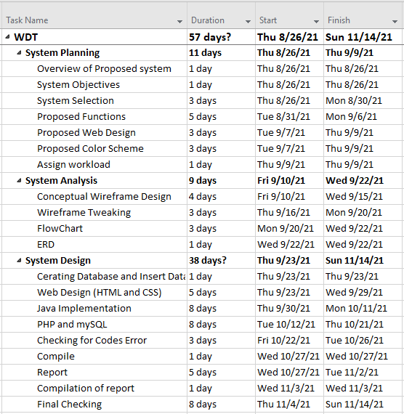

**Figure 1: Gantt Chart Table**

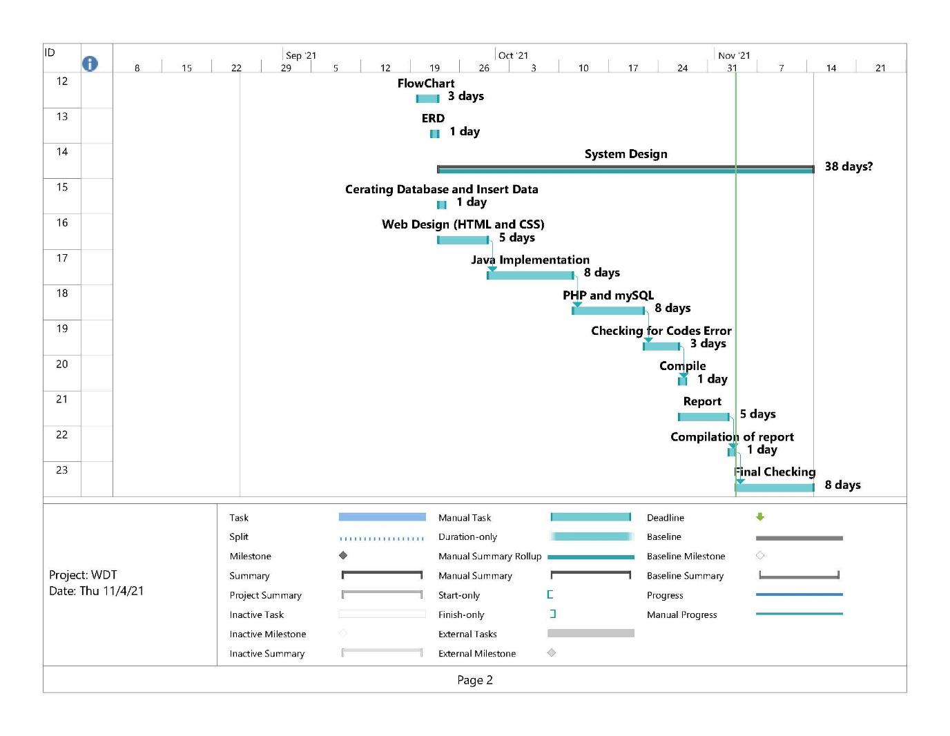 **Figure 2: Gantt Chart**

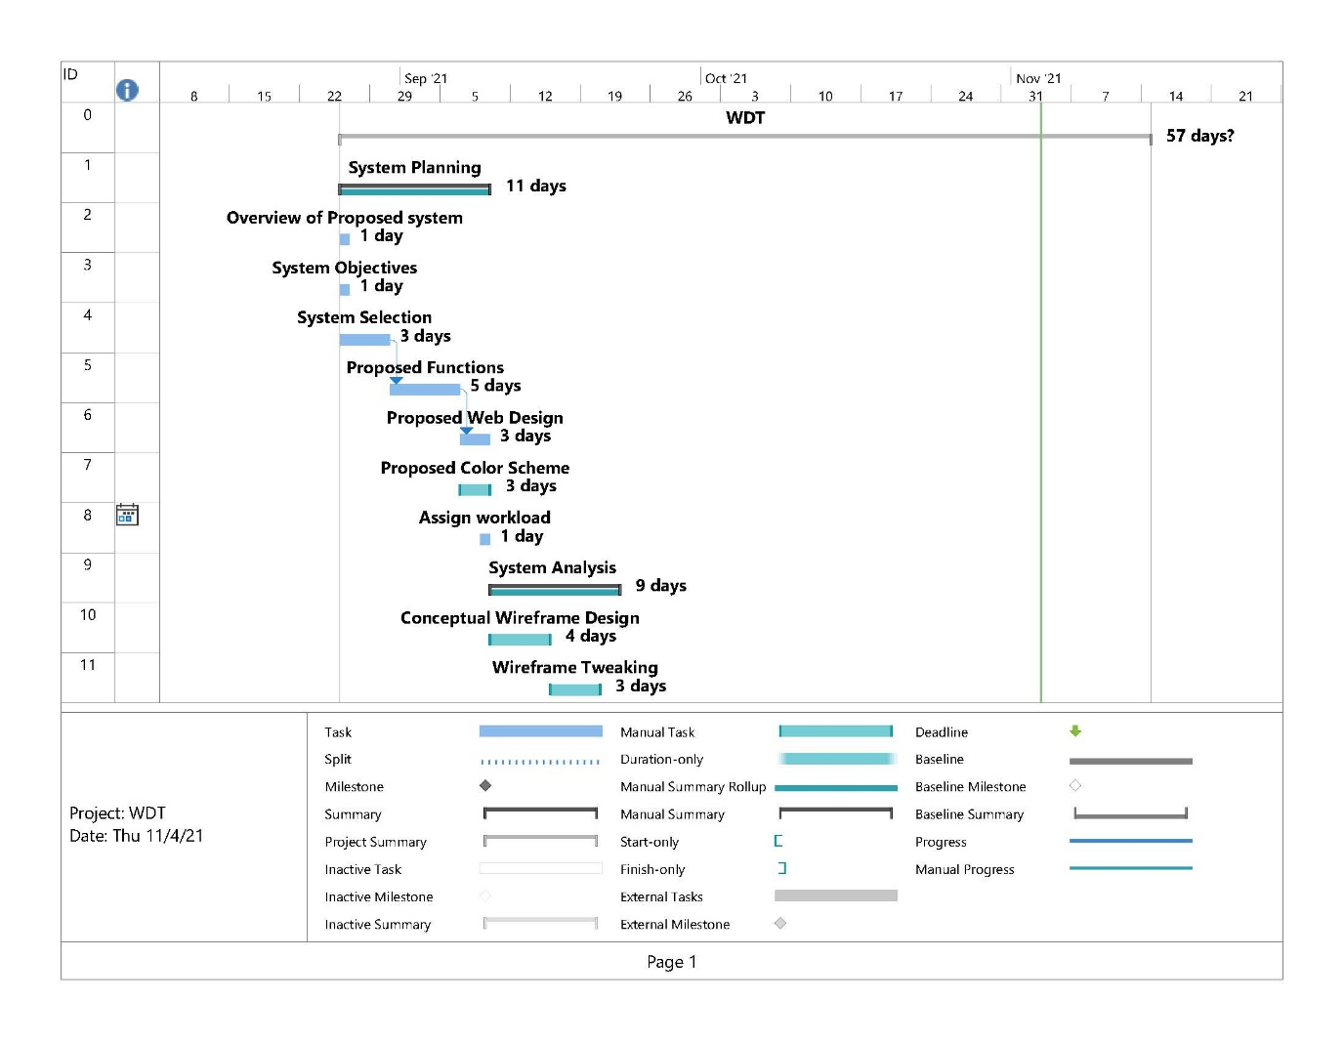**Figure 3: Gantt Chart**

# Introduction and Objectives of the project

Sum is a website of a restaurant based around the culture of traditional Chinese food which is dim sum. Dim sum is a classic Chinese dish consisting of tiny plates of dumplings and other snacks, served with tea. The dim sum website was built with the goal of being able to view and order the menu through online as an effort to expand the restaurant to an online presence. The website overall has reached several of our objectives and expectation which stated as below.

* To create a simple and modern design
* To create a user-friendly interface
* To create a shopping cart so that customer able to make their payment
* To create an easy to view menu
* Create a Login and Register feature
* Create a feature that customer able to update their information
* To create an admin page that allow to manage item.

Dim Sum provide delivery services using for those customers who does not wish to leave their house due to any reason. Delivery service is available made using Food panda, Grab & Hungry. There is form provided to visitor to fill out to create a new account and user account information will be saved. By implementing a feature that allow customer to edit or update their information once their information have changed. Administrator able to edit the name and price of food based on the admin page functions provide with increase the efficiency of the administrator. At the same time, the admin also can add new category for the food and beverage after they login to the admin website.

Our website design will be more minimalistic with the focus on user experience and ease of navigation. There is shopping cart provided in the navigation bar to customer so that can gather their foods in the cart. The design will increase the user-friendly of targeted audience which is young man so that they will not get confused will our website. The reason of targeted audience chosen to young man is because most of the young man would prefer to use online food delivery compare with senior.

# System Design

## Wireframe



**Figure 4: Home Page Wireframe**

|  |  |
| --- | --- |
| Screen Name | Homepage |
| User(s) | Customer |
| Description | “Marketing” will be replaced with the content of the website which include introduction of the restaurant. |

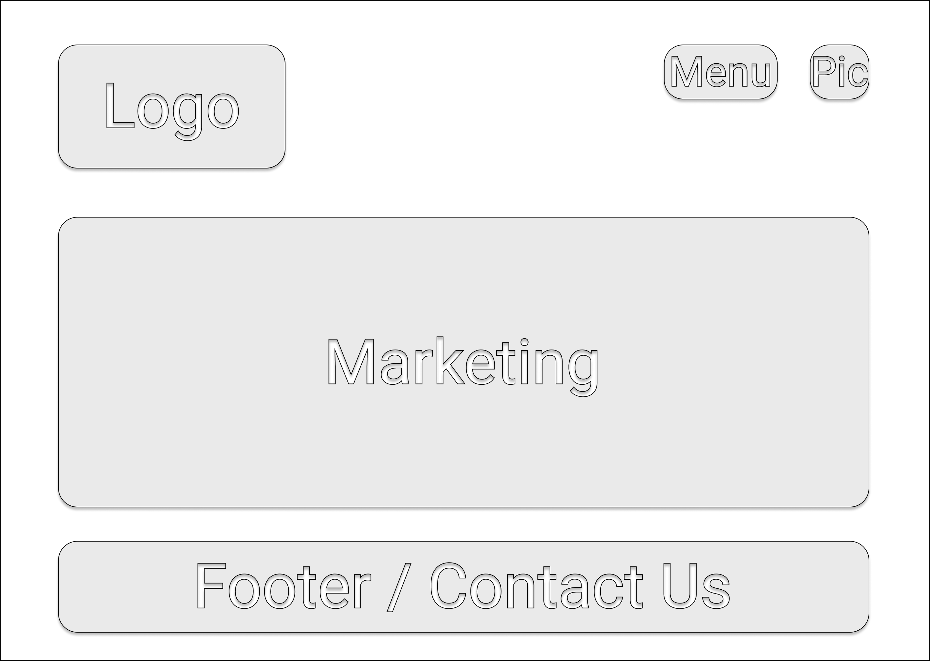

**Figure 5: Home Page After Login Wireframe**

|  |  |
| --- | --- |
| Screen Name | Homepage After Login |
| User(s) | Customer |
| Description | “Pic” will be replaced with the profile picture of customer which can be redirect into log out and edit account details when hover over the profile picture. |

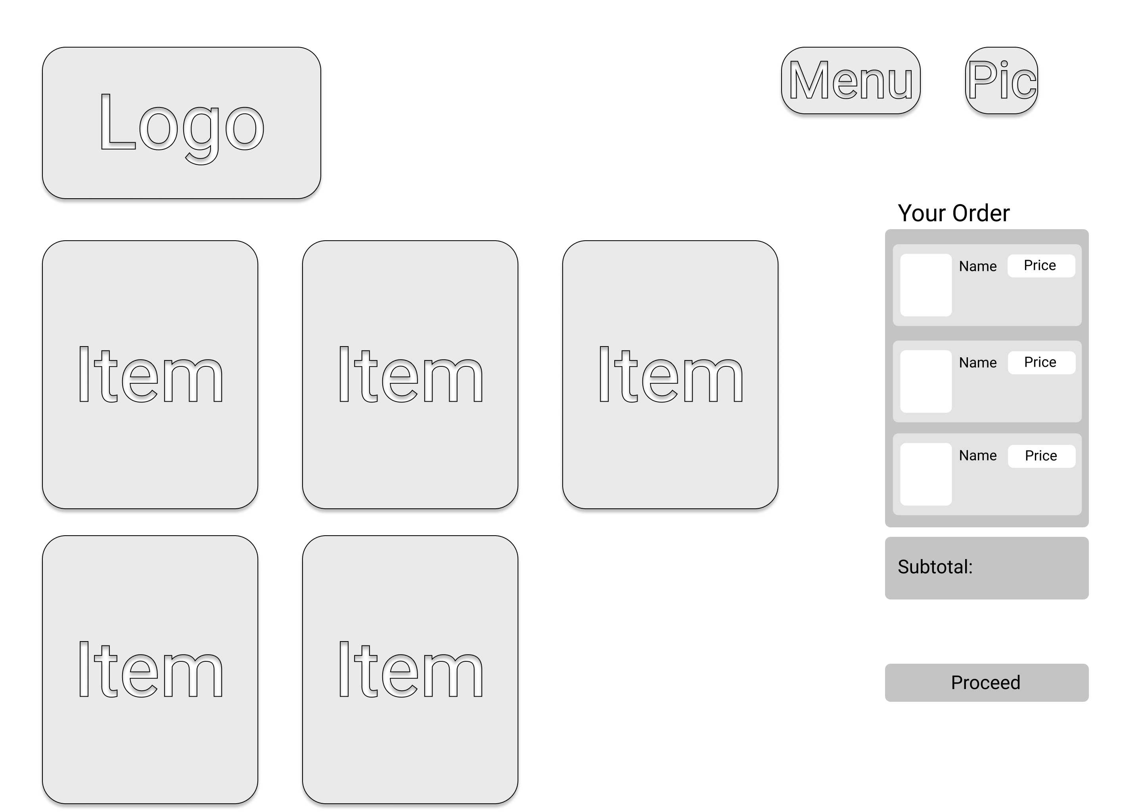

**Figure 6: Main Menu Wireframe**

|  |  |
| --- | --- |
| Screen Name | Menu Page |
| User(s) | Customer |
| Description | “Item” will be replaced with our dim sum that will be retrieved from database. The item will be added into “Your Order” by clicking a button. |

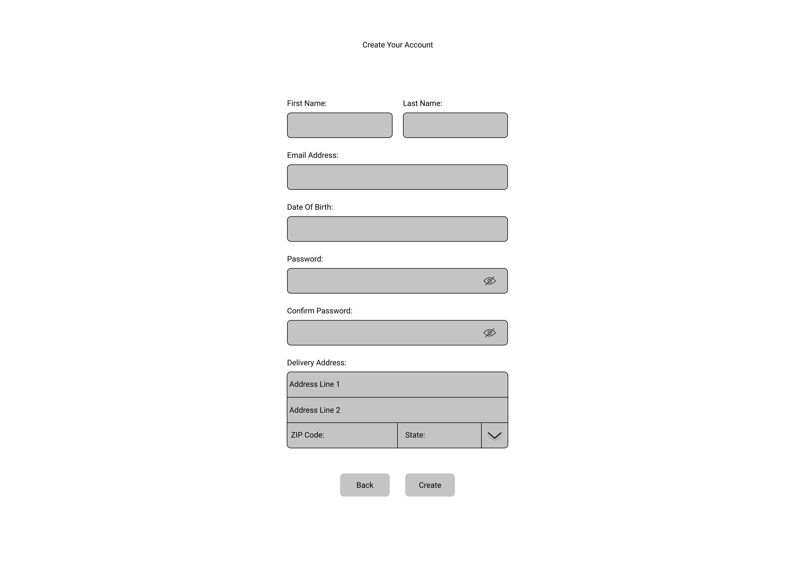 **Figure 7: Create Account Page Wireframe**

|  |  |
| --- | --- |
| Screen Name | Create Account Page |
| User(s) | Customer |
| Description | “State” can be clicked to choose one of the states of Malaysia. |

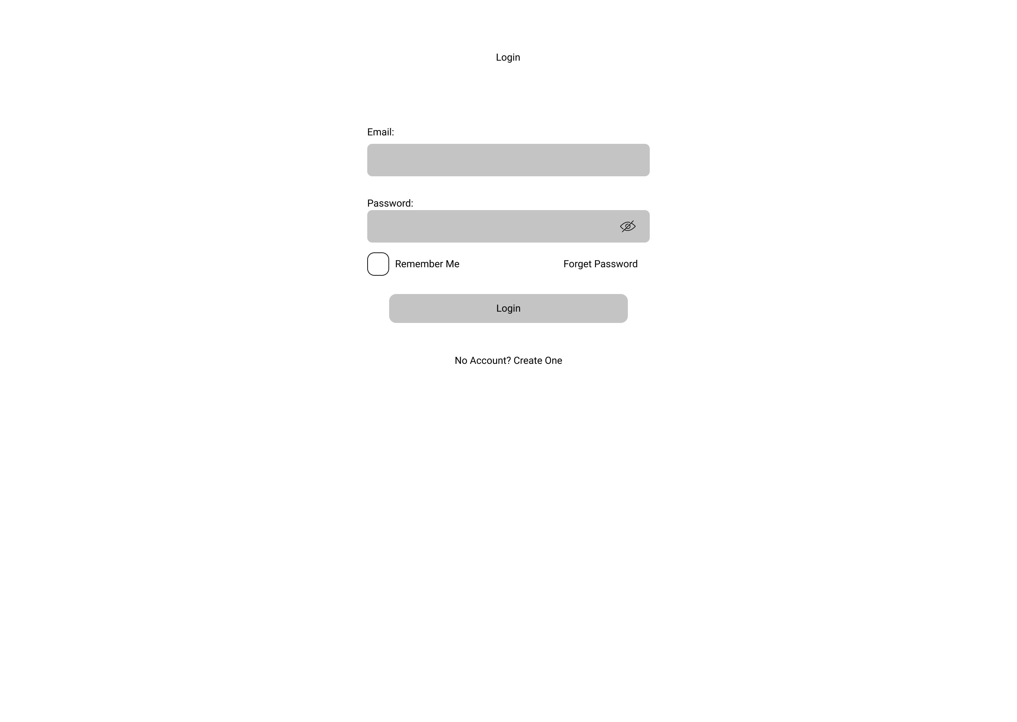

**Figure 8: Login Page Wireframe**

|  |  |
| --- | --- |
| Screen Name | Login Page |
| User(s) | Customer |
| Description | “Create One” of “No Account? Create One” can be clicked to be redirected to Create Account Page. |

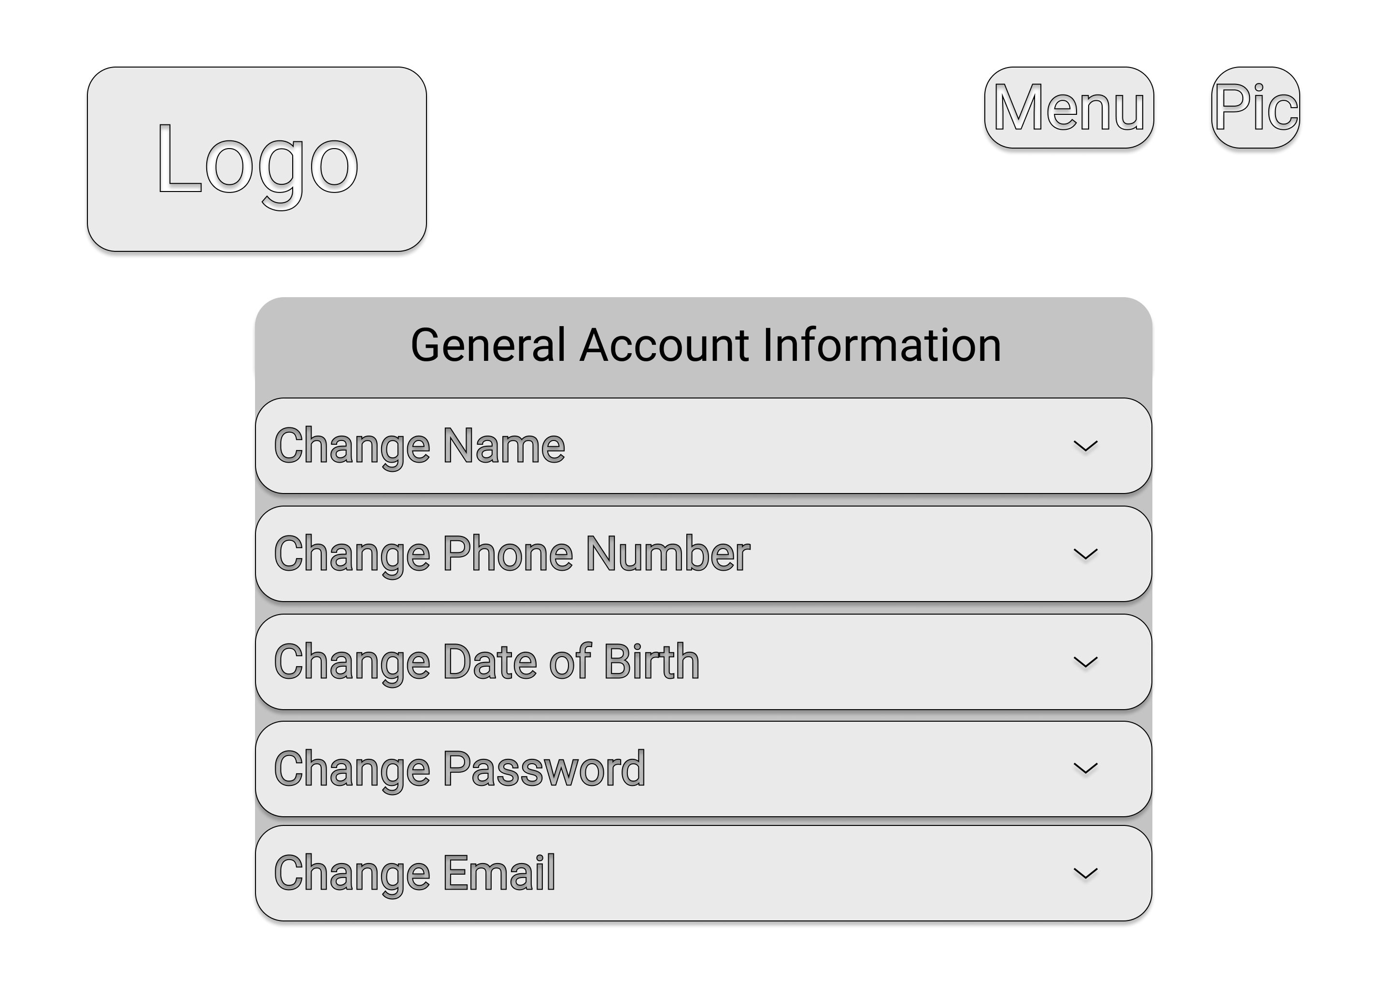 **Figure 9: Account Setting Wireframe**

|  |  |
| --- | --- |
| Screen Name | Account Settings Page |
| User(s) | Customer |
| Description | All “Change <Settings>” can be expanded or collapsed to change the desired setting by customer. |

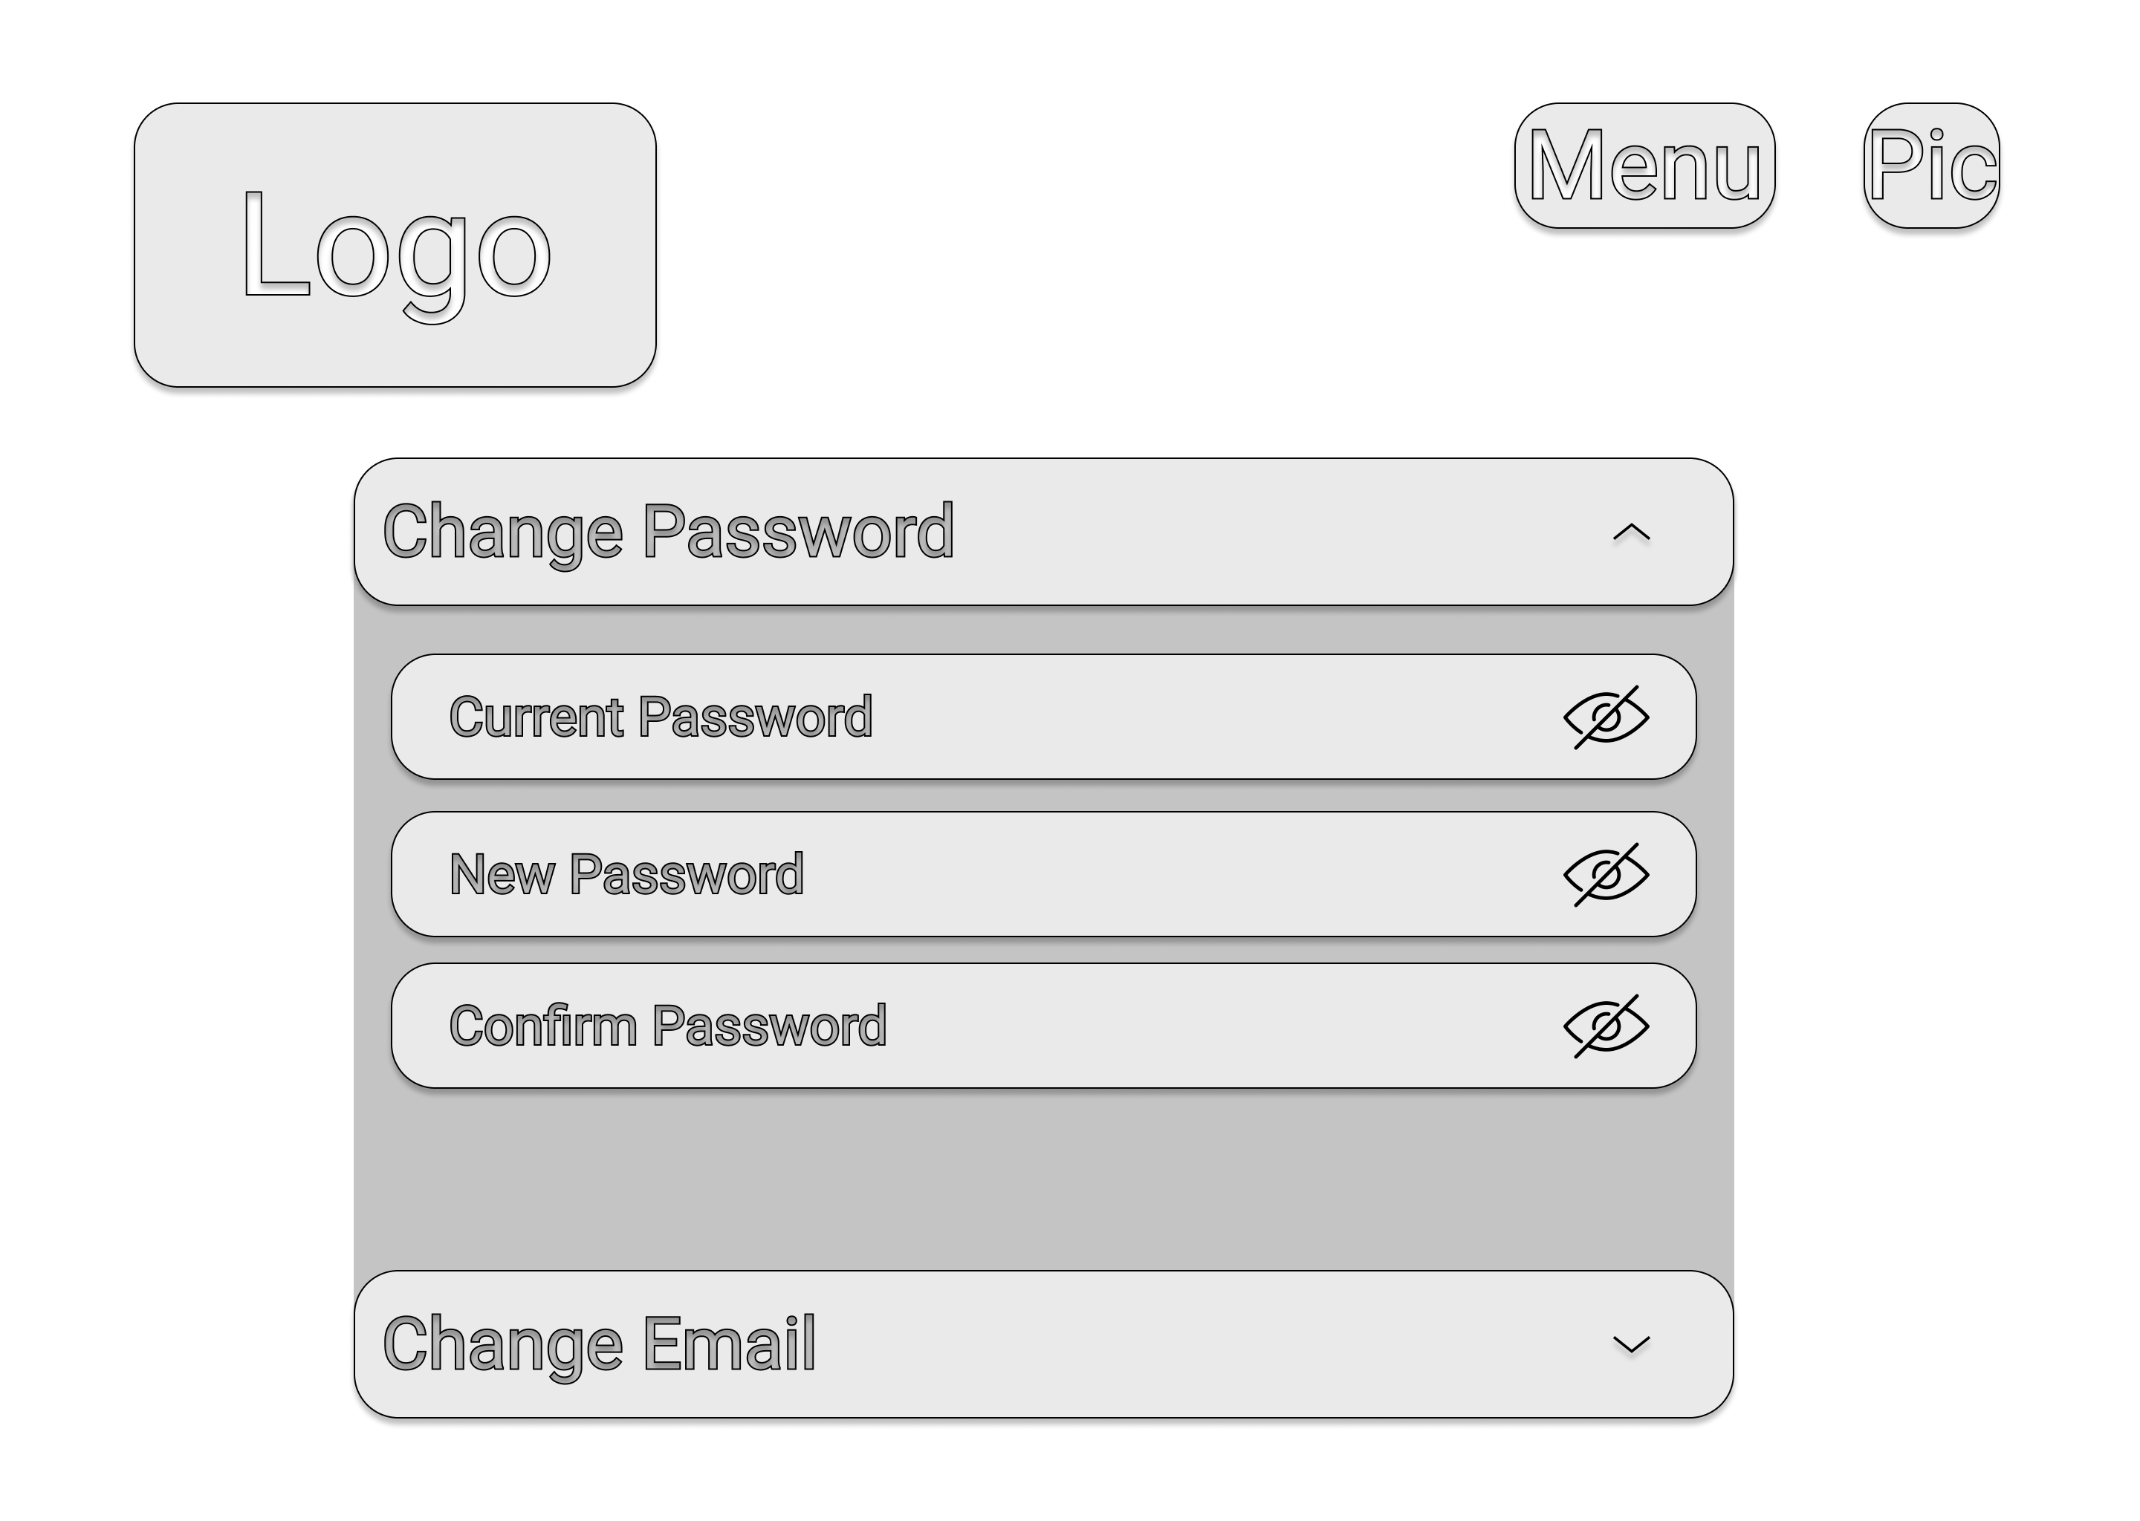

**Figure 10: Change Password Wireframe**

|  |  |
| --- | --- |
| Screen Name | Expended Cell of “Change Password” |
| User(s) | Customer |
| Description | Interface after “Change Password” had been expanded. Password will be hidden with asterisk symbol ‘ * ’ to ensure password would not been seen by others. |

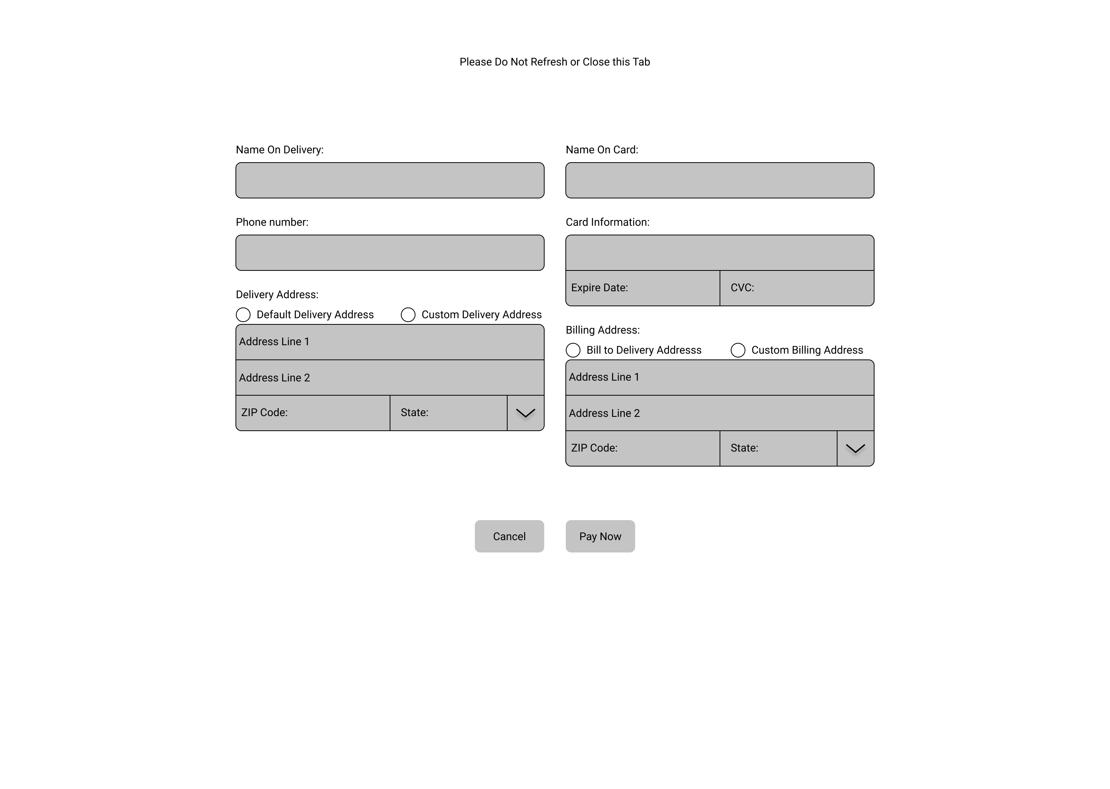

**Figure 11: Payment Page Wireframe**

|  |  |
| --- | --- |
| Screen Name | Payment Page |
| User(s) | Customer |
| Description | “Default Delivery Address” will retrieve customer address that was stored into database when customer create their account. “Default Delivery Address” will be selected by default, but Customers are able to select “Custom Delivery Address” to enter their preferred delivery address. |

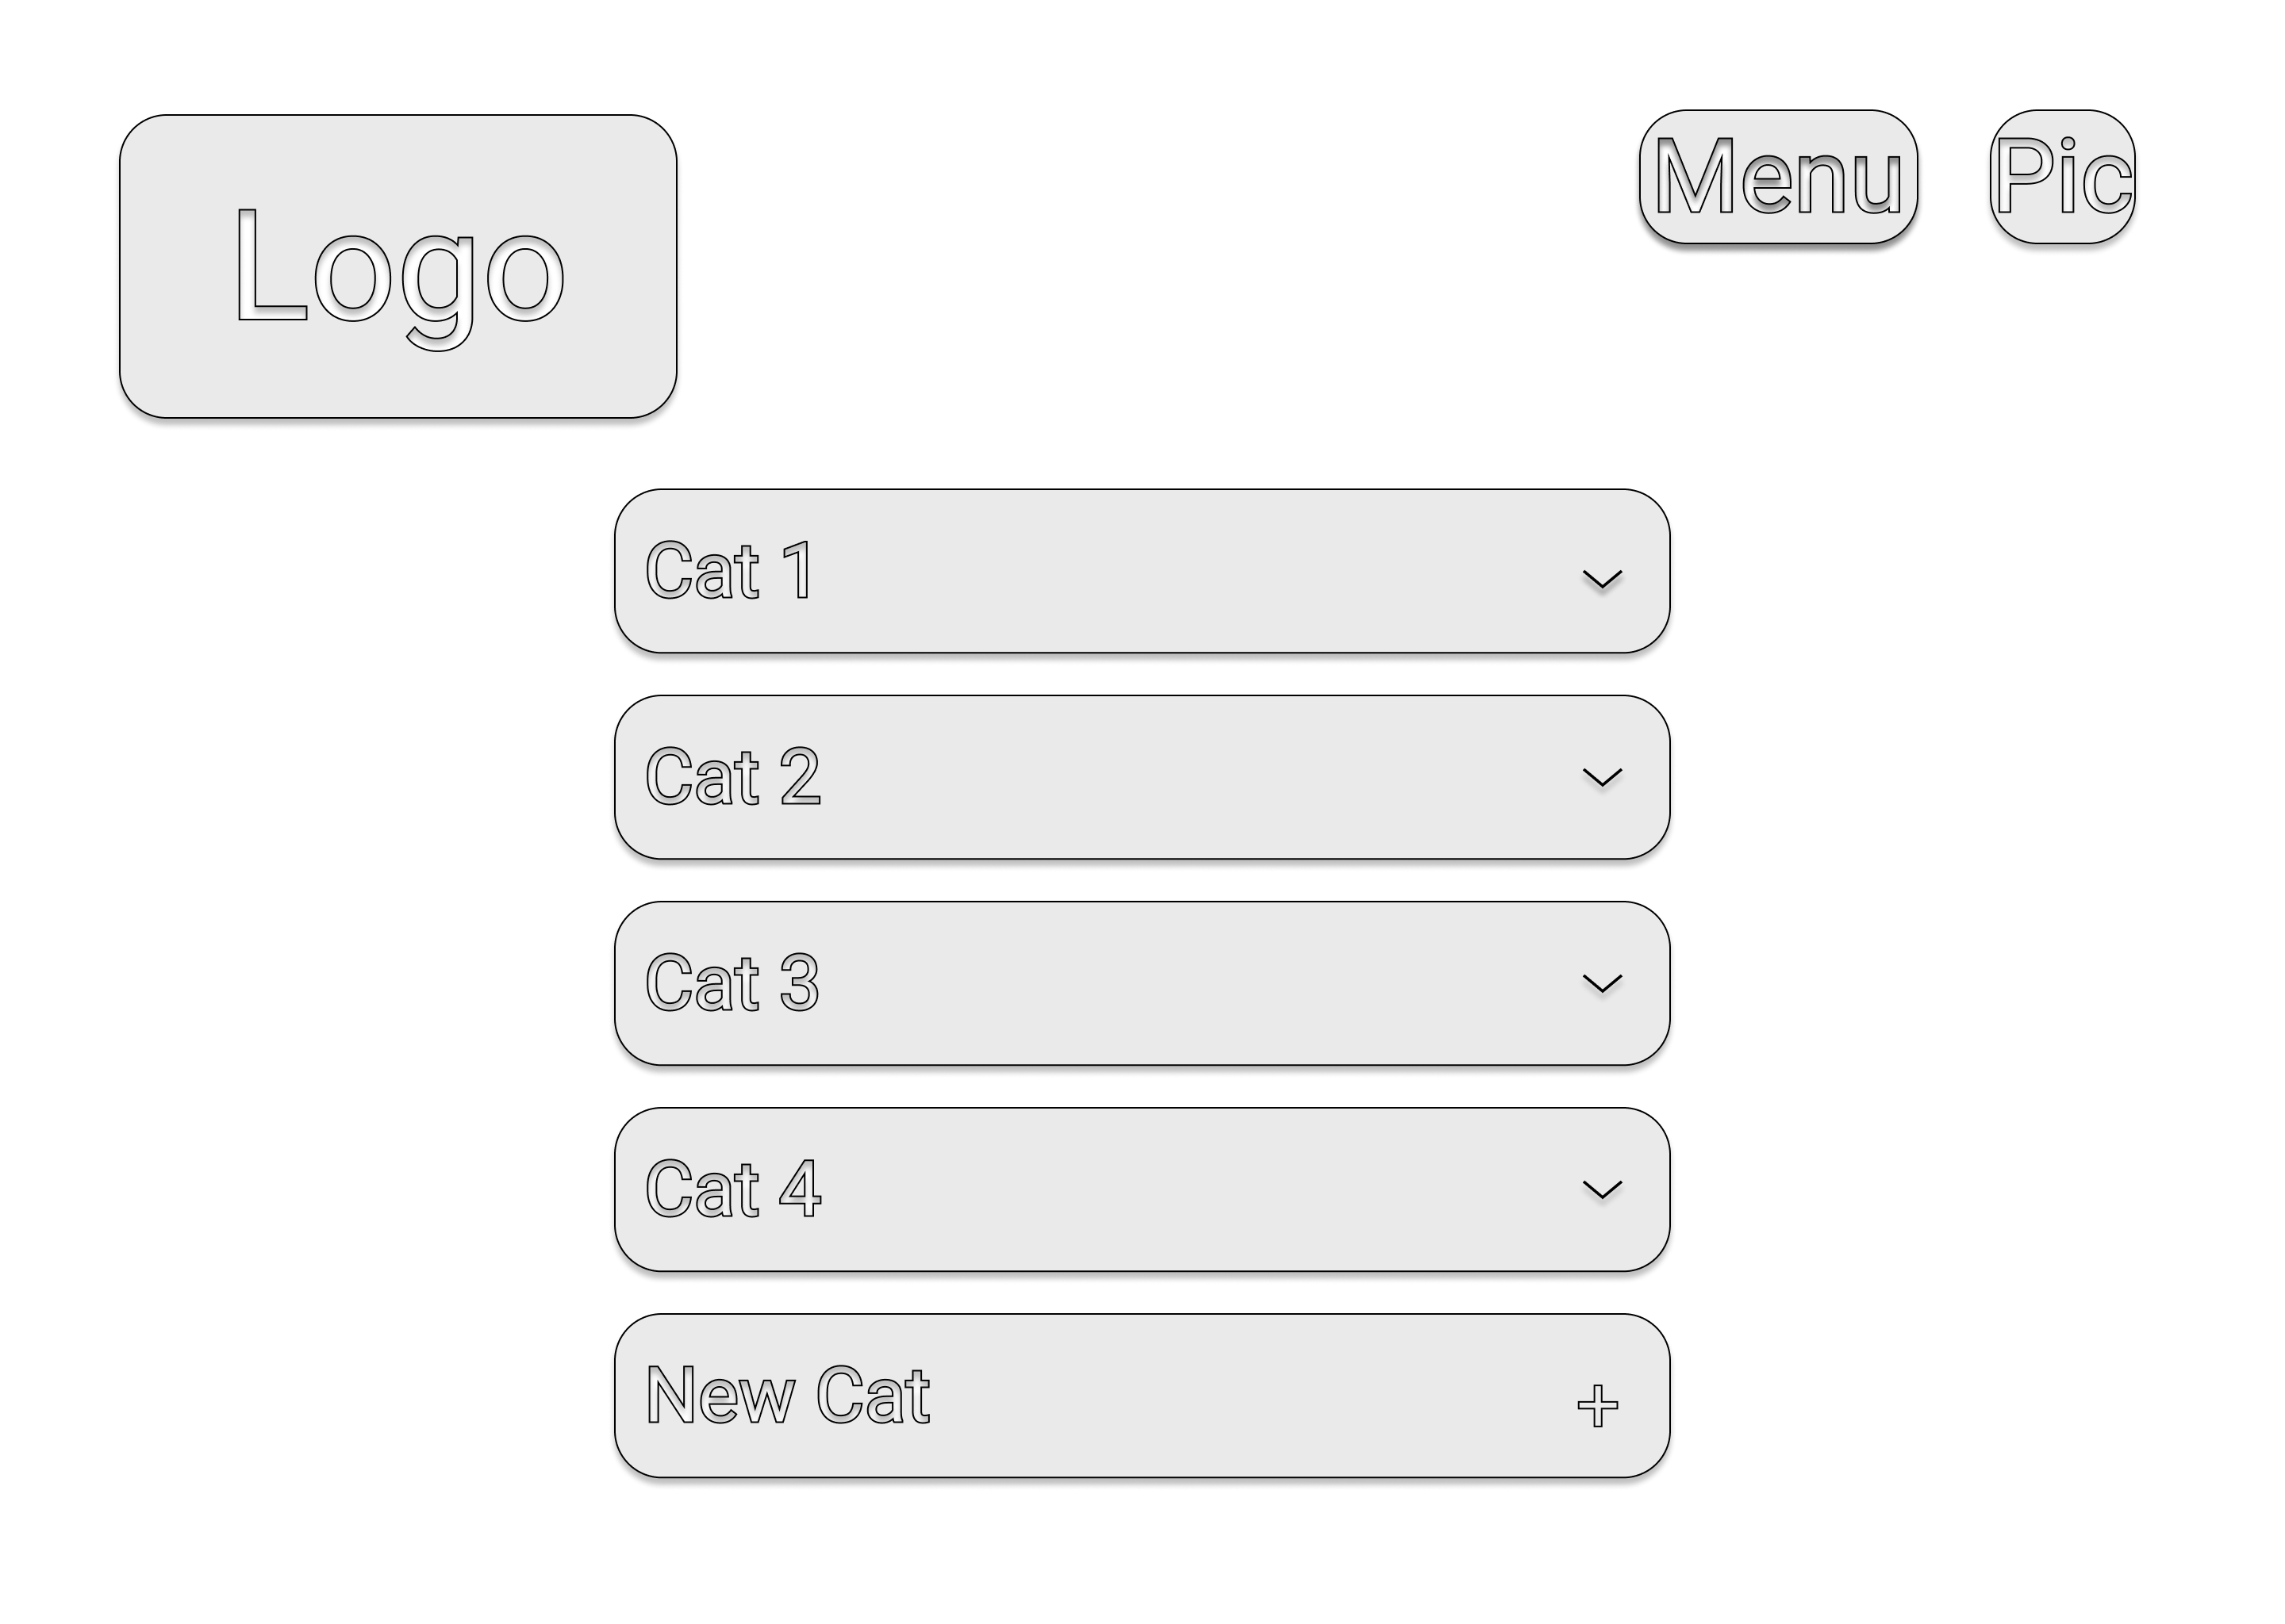

**Figure 12: Menu Settings Wireframe**

|  |  |
| --- | --- |
| Screen Name | Menu Settings Page |
| User(s) | Admin |
| Description | All “Cat <Number>” will be replaced with the category of food of the dim sum available in the database. “Cat 1” can be clicked to expand or collapse the cells to reveal or hidden available dim sum.  “New Cat” will enable admin to type a new category and add it into the menu. |

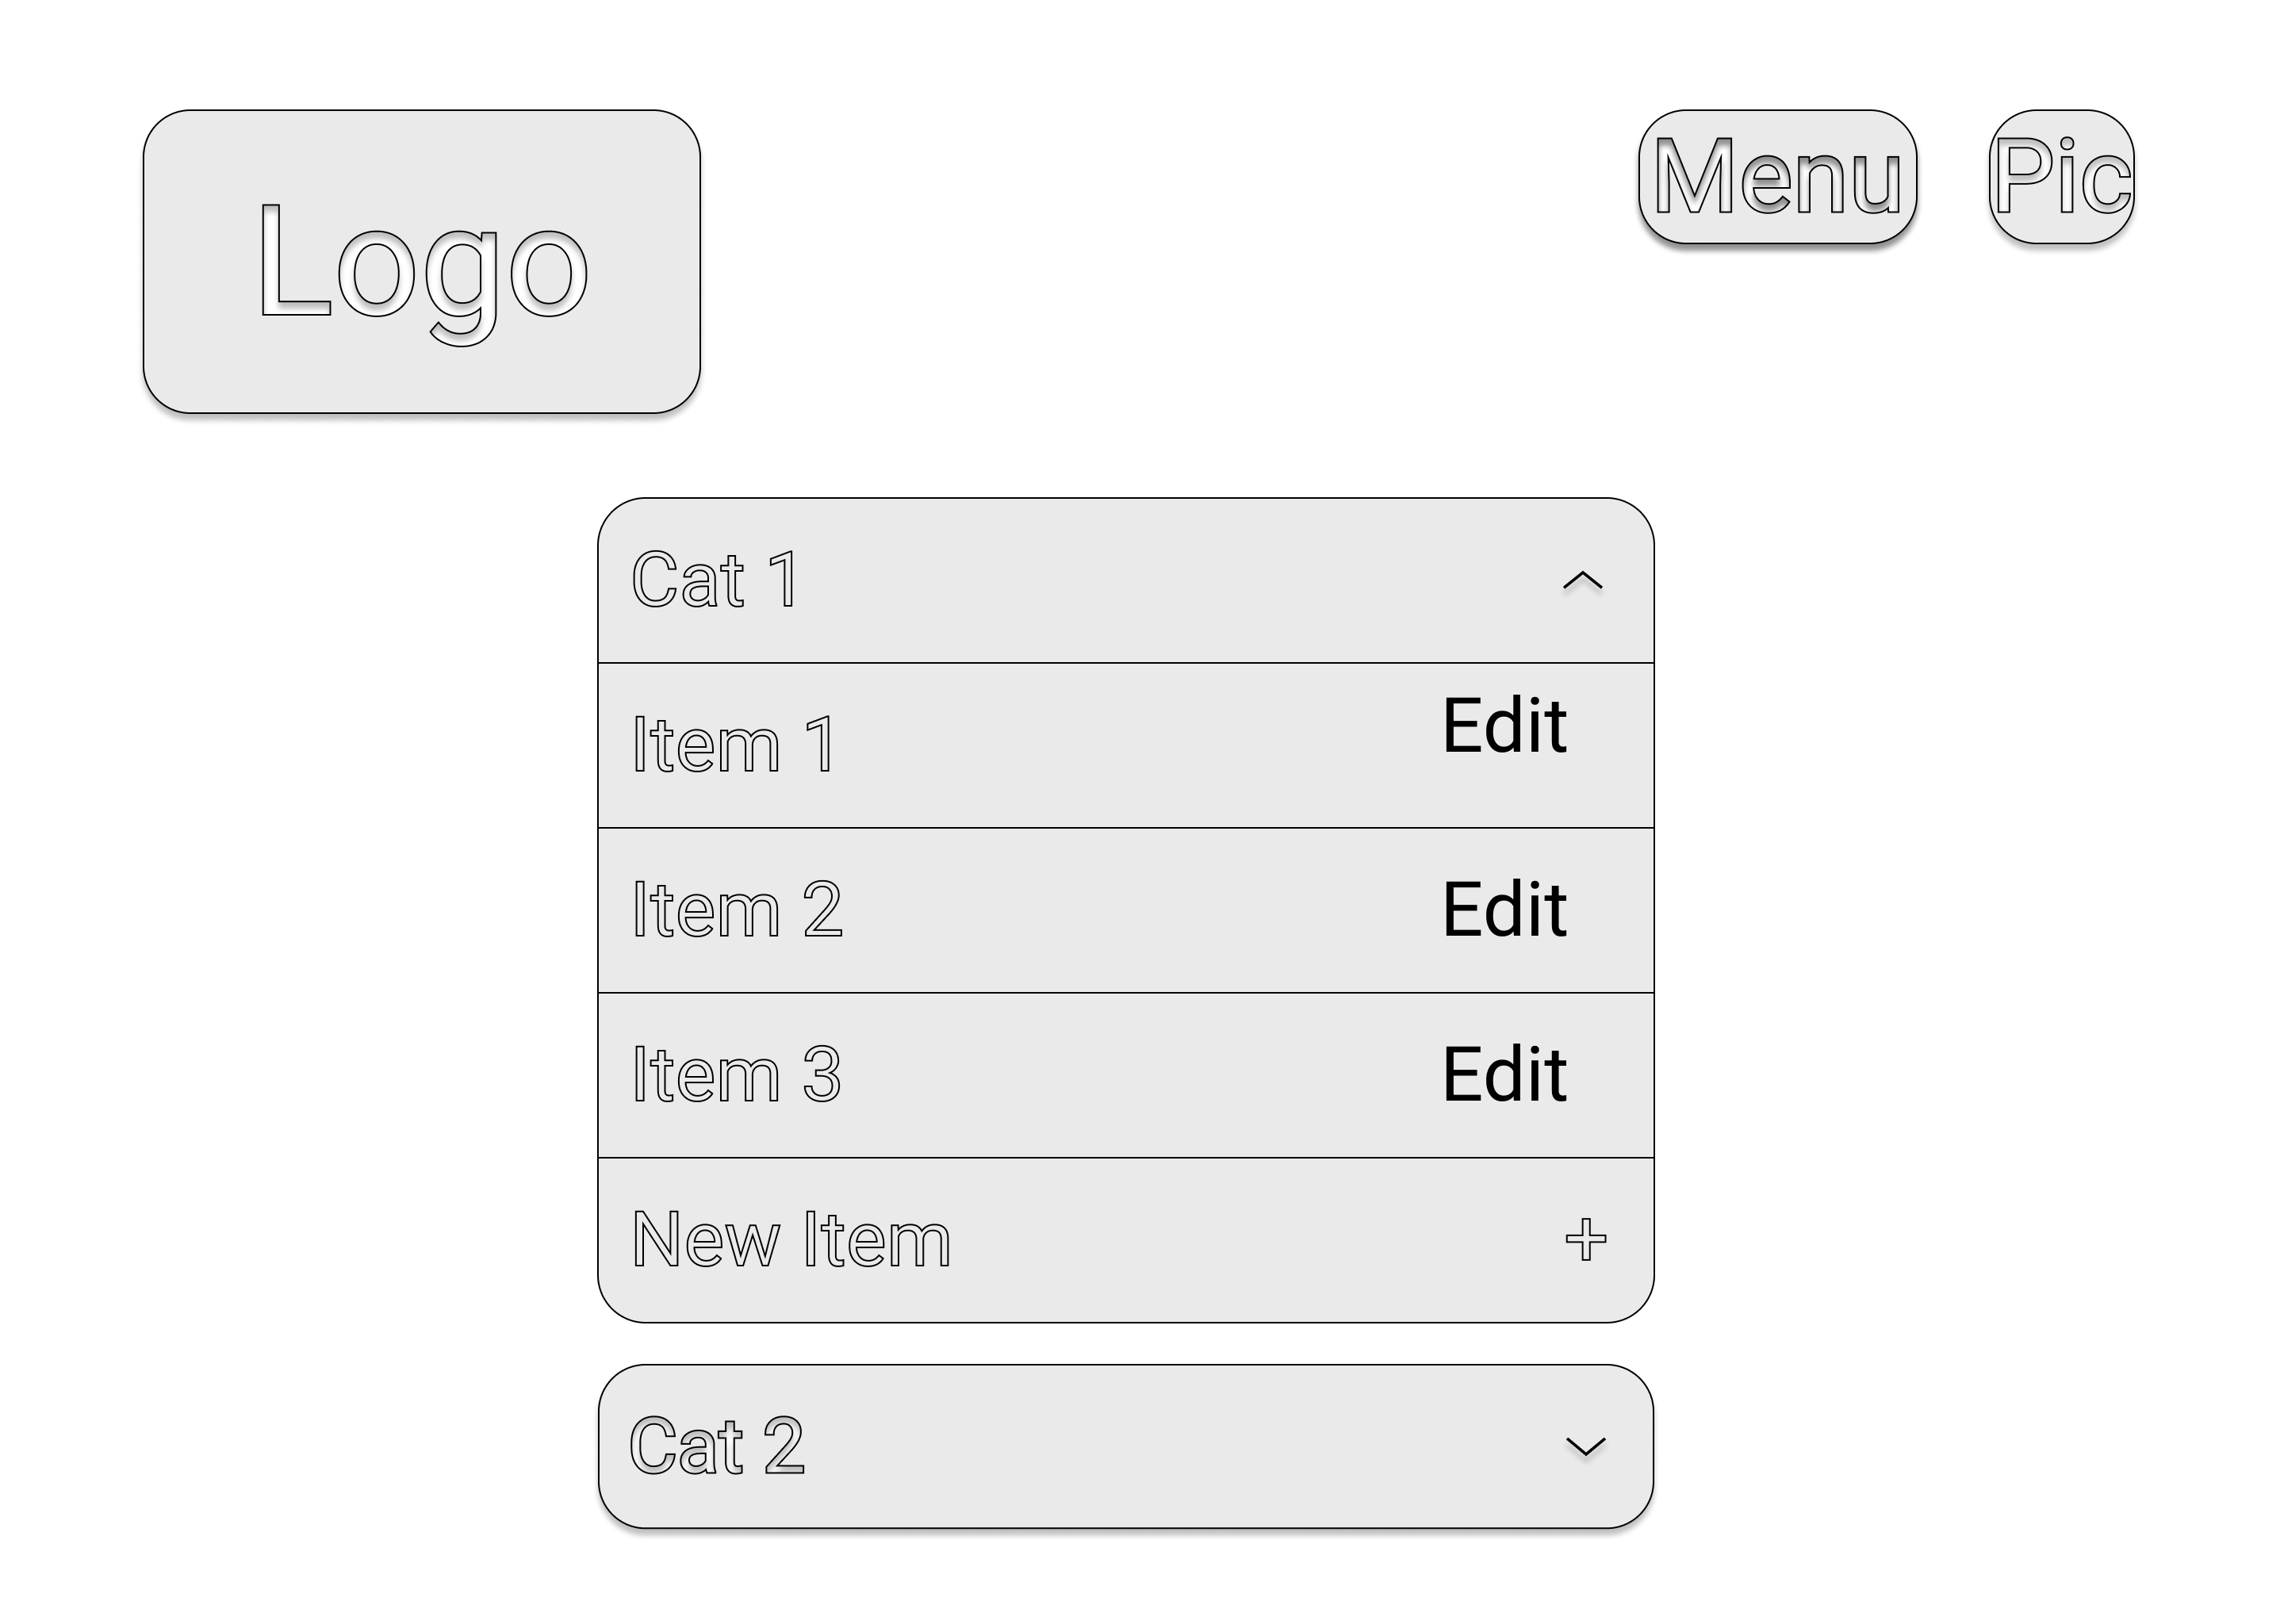

**Figure 13: Change Menu Wireframe**

|  |  |
| --- | --- |
| Screen Name | Expanded Cell of Menu Settings Page |
| User(s) | Admin |
| Description | The interface after admin clicked on “Cat 1”. Each “Item” will be replaced with the name of each dim sum. Admin will be able to edit the information of every “Item” |

## Navigational Structure

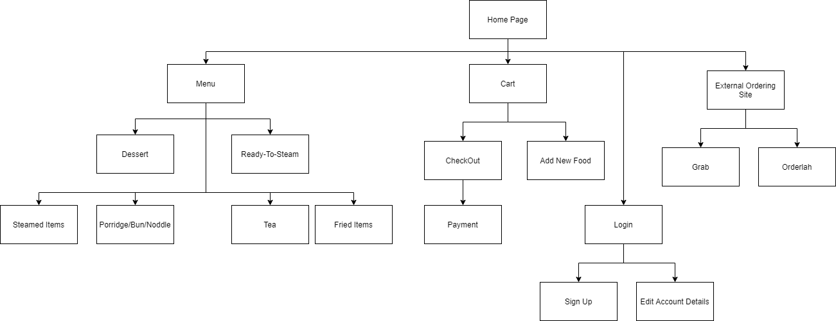

**Figure 14: Navigational Structure**

## Flowchart

### Login and Sign Up

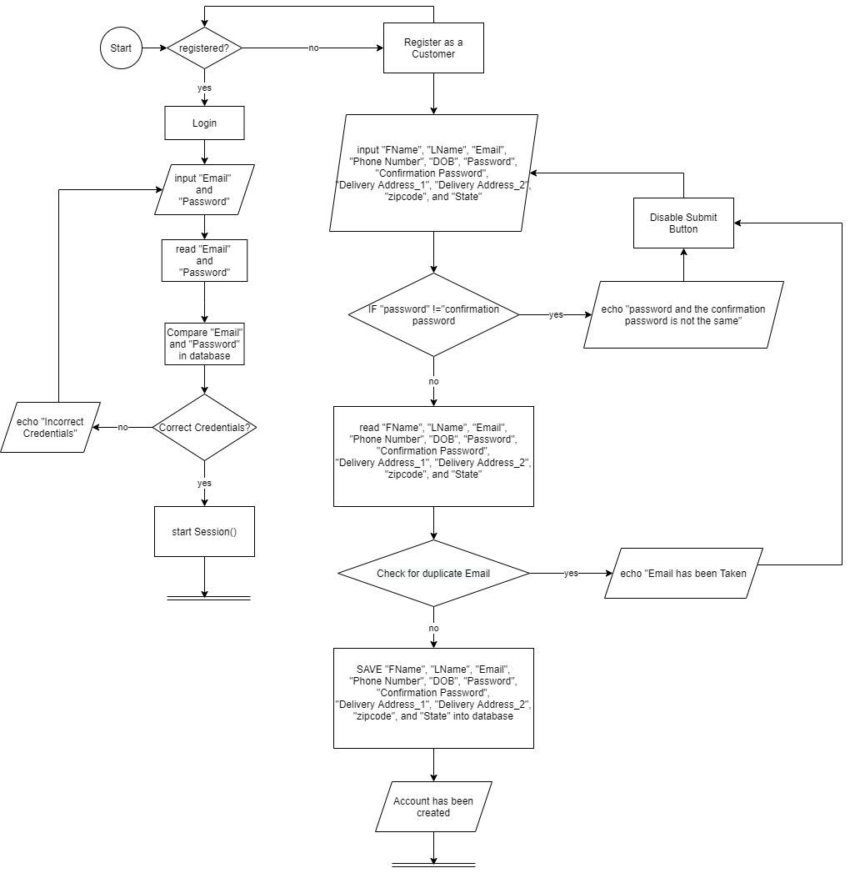

**Figure 15: Login and SignUp Flowchart**

The Flowchart above is the flowchart for login and signup function. To login, the user is required to enter their Email and Password. If they enter their Email or password wrongly, they won’t be able to log into their account.

To create an account, they are required to insert their first name, last name, email address, phone number, date of birth and delivery address. Noted that Email address is used for login, therefore the email cannot be duplicated. If the user enters an email that already exist in the database, the webpage will prompt an error saying that the email has been taken.

### Edit User Account

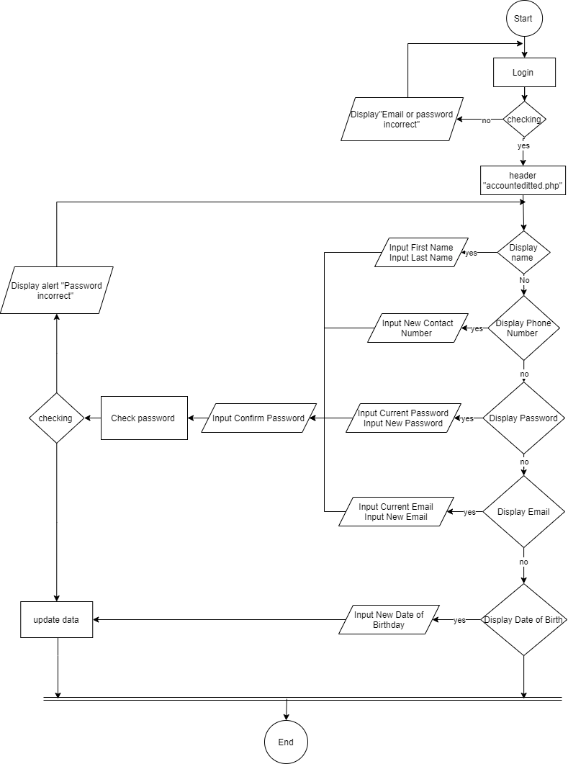

**Figure 16: Edit User Accounts Flowchart**

After the user login to the system, the user will be directed to “accounteditted.php”. The user’s information will be displayed such as name, phone number, email, and date of birth except of password. User can modify their information by clicking the logo edit and enter their new information. Users require to enter password to update their new information. If the password was wrong their will not be able to update their information and an alert message will pop up, then redirect user back to page.

### Food Menu and Cart

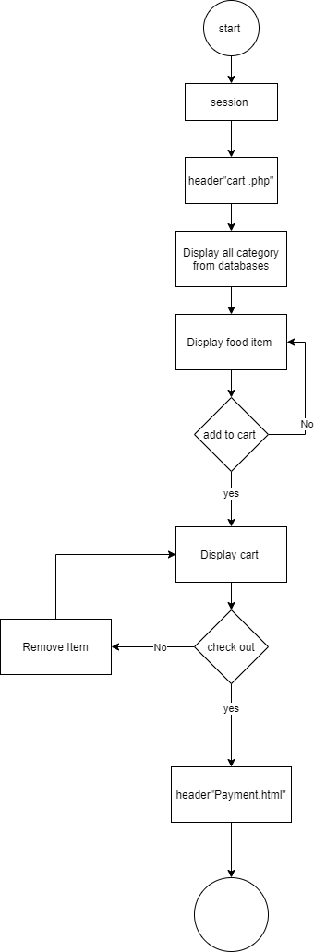

**Figure 17: Food Menu and Add to Cart Flowchart**

Once the user is redirected to the “cart.php” after clicking the menu link in the navigation bar. The category and category item in databases will be displayed on the page. Each item will then be provided a add to cart button so that users are able to add the item they wish into cart. User either opt to remove an item out of the cart or proceed to checkout. They will then be redirected to payment.html.

### Payment

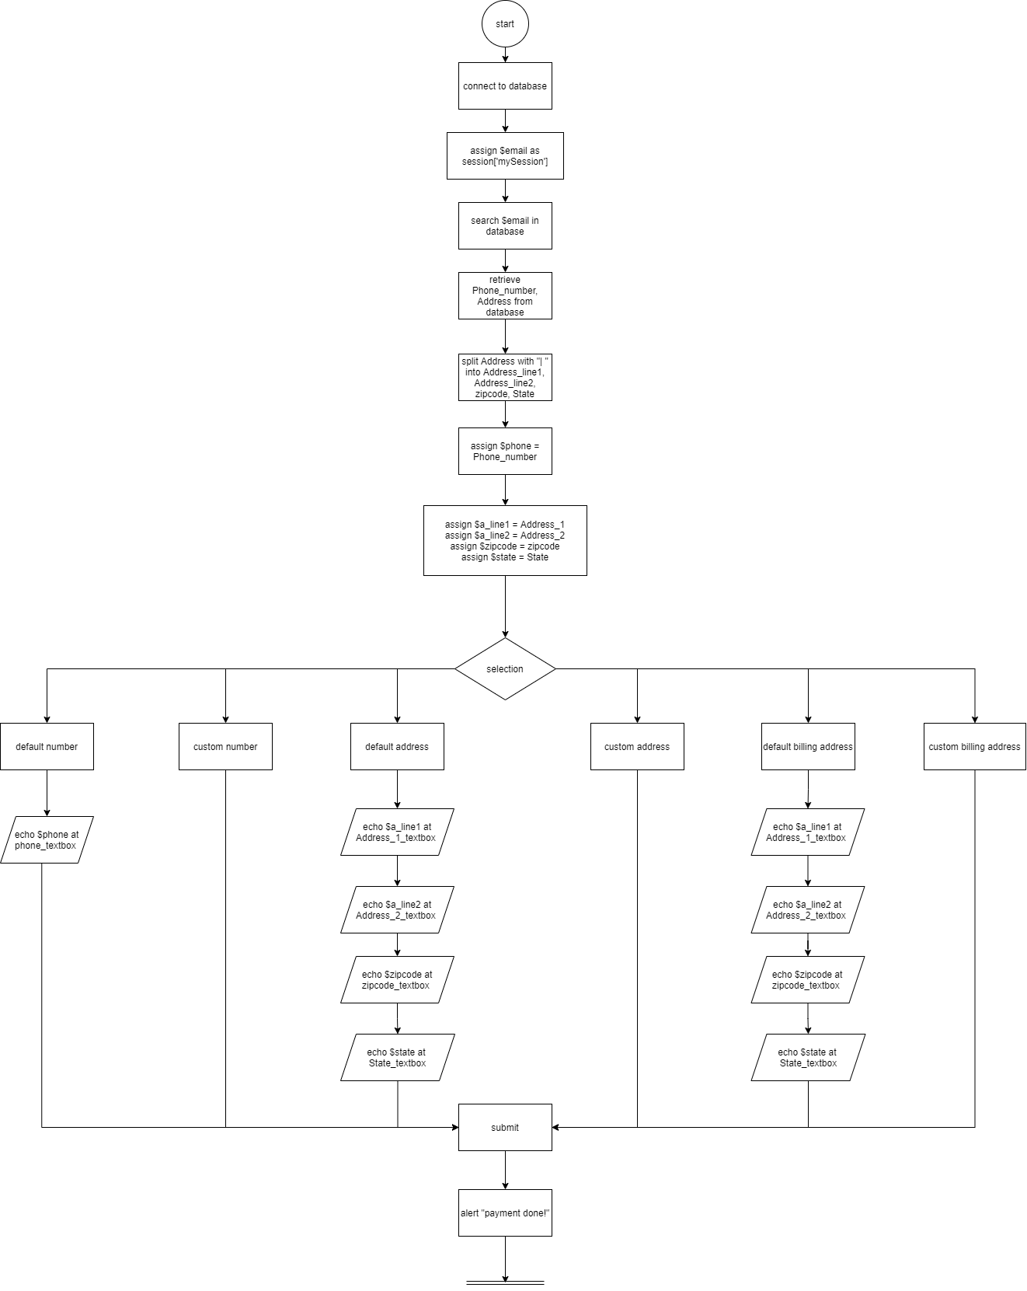

**Figure 18: Payment Flowchart**

The flowchart above is the flowchart of payment page, users are required to fill in their details such as Name on Delivery, Phone Number, Delivery Address, Name on Card, Card Number, Card Expire Data, CCV of the card, and Billing Address. User can choose to use Default Number/ Custom Number, Default Delivery Address/ Custom Delivery Address, and Default Billing Address/ Custom Billing Address. If the user chooses default of any of the selection, the page will retrieve their personal data and fill it automatically into the input box.

### Admin Login

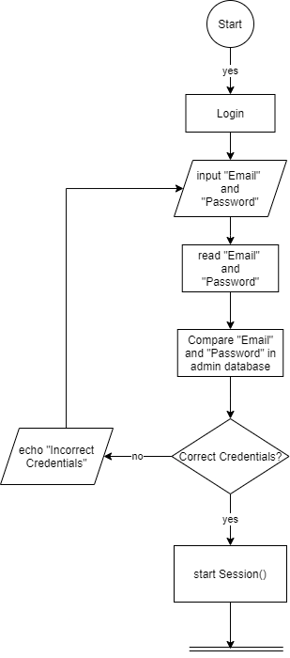

**Figure 19: Admin Login Flowchart**

The flowchart above is the flowchart for admin login, admin is required to enter his email and password to access the admin page, if he enters his email and password wrongly, he will not be able to log in to his admin account. After logging in, a session will be created for the admin and the admin will be able to access the admin function.

### Admin Function

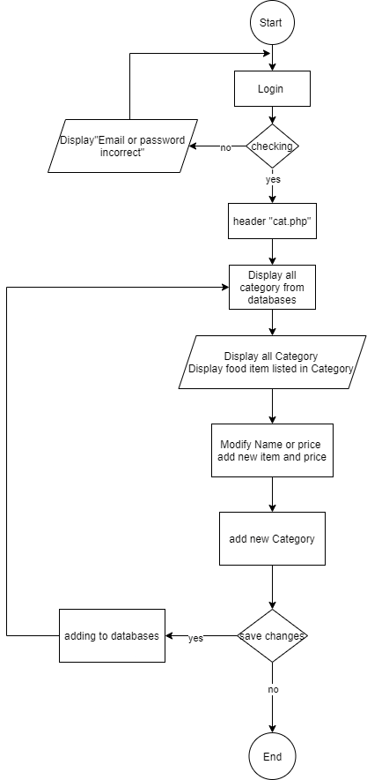

**Figure 20: Admin Function Flowchart**

After the user login to the system, the user will be directed to category pages which allow admin to do any modification on it. The Category will be displayed same as the Category in databases. Each of the food and beverage will also echo from databases in Categories. Admin able to edit the name and price to all the food and beverage in the pages. In additional, the admin also able to add new category based on the function provided and the category will be stored in databases after admin click save changes.

## ERD

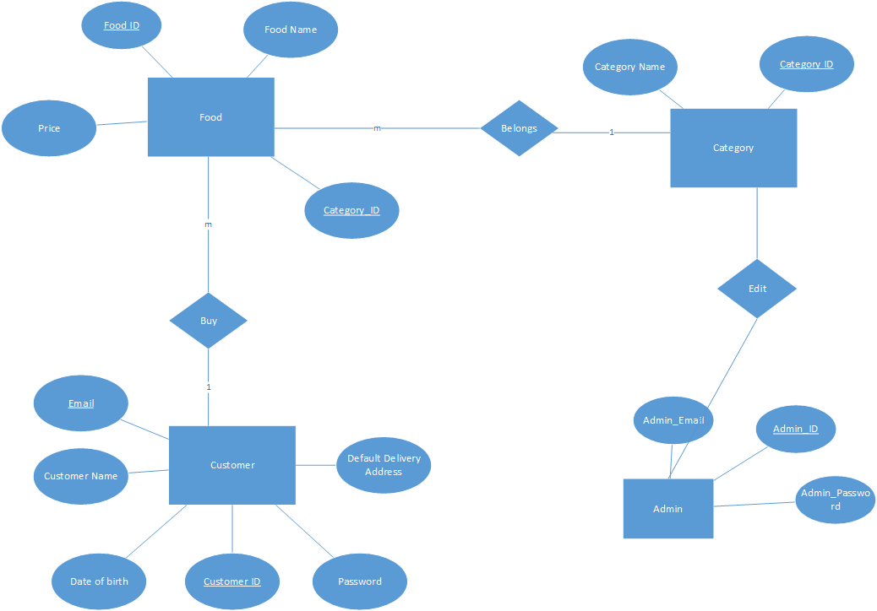

**Figure 21: ERD Diagram**

# Implementation

## Create

### HTML

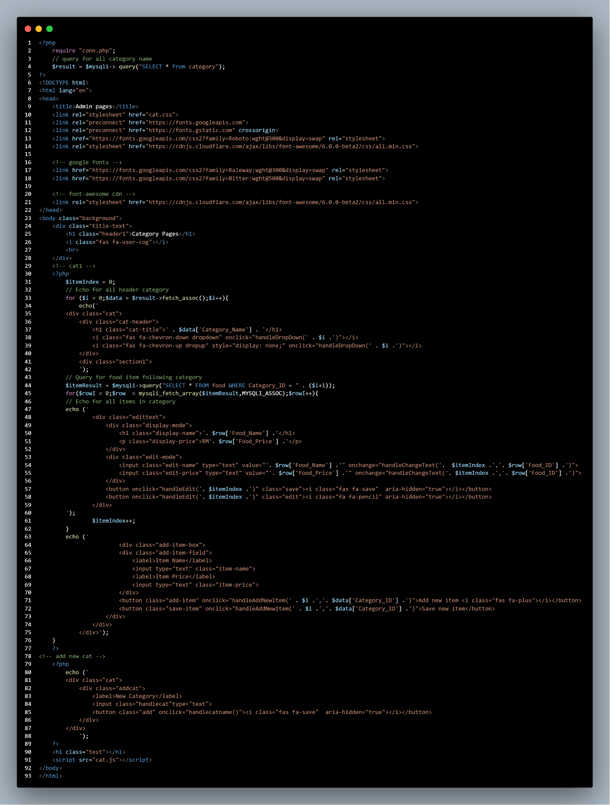

**Figure 22: Create HTML code snippet**

The figure above is the combination of Html and Php for the create function of admin page. After the Admin login to the account then it will redirect to category page. The code starts with linking a connection php file to the server so that data can be retrieved from the server. The external CSS also links in between head element. For loop used to retrieve all the category item in server and displayed in the webpages.

To create a category, user must enter the new name for the category and click the button provided. When user clicks the button, it will trigger a java script function that create an Ajax request to an external Php file.

PHP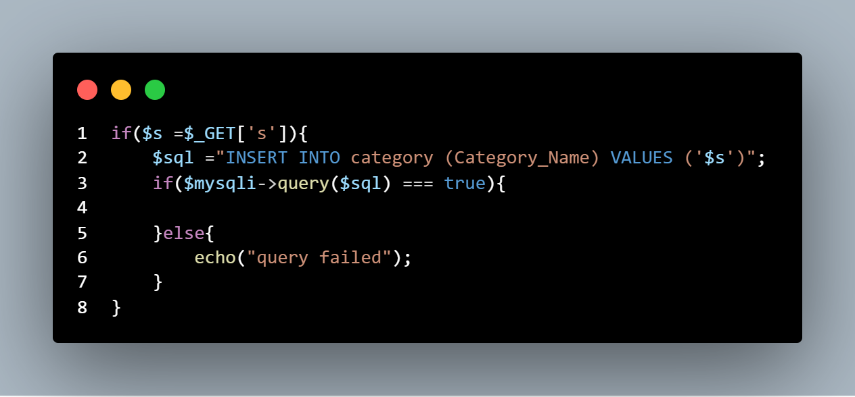

**Figure 22.1: Create PHP code snippet**

The figure contains a query that is used to create a new category in the databases when an ajax request is received. The if statement is to check the query is successful or unsuccessful so that user know the information whether save in server.

## Read HTML and PHP form

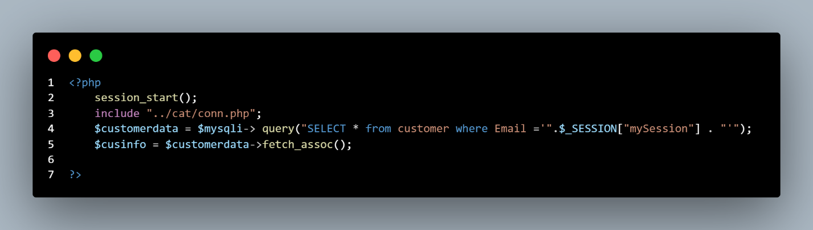

**Figure 23: Read HTML code snippet**

In the figure above the code first will establish a connection into the databases then execute a query to get the current login user information. In line 4 a variable is created to read the result query from the databases.

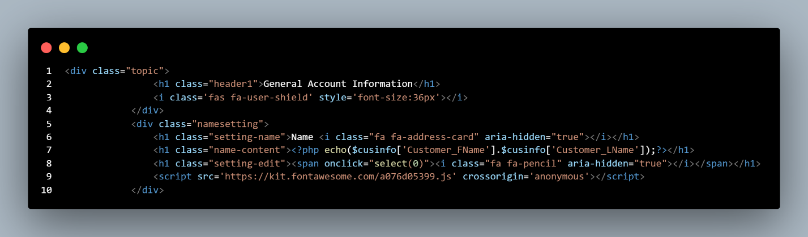

**Figure 23.1: Read PHP code snippet**

After the variable read the query, then the variable can display the item of the databases by using Php to echo out in line 7. The figure below is the example of the result.

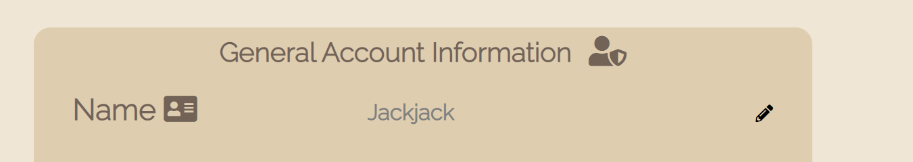

**Figure 23.2: Read UI Example**

## Update

**HTML

**Figure 24: Update HTML code Snippet**

The figure above is the combination of Html and Php for the update function of the project. The page is linked with Php file in line 3 and Php session is used in line 2 for storing user information when user login. A variable is assigned to retrieve and process the data from databases in line 4 and 5. All external CSS have been linked in line 13 to 20. The function “label” is applied in html for labelling the information user data when it is retrieved from server. The “class” can also be seen in most of the line, because all the code has been assigned with CSS or JavaScript to perform certain commands.

The form action is used to send the form data and method “POST” is used to create or update a data to a server as the line 37 shown. Each User information are created a form action such as Name, Phone Number, Email, Password and so on. While user input their new Information, it will be sent to the server for update.

### PHP

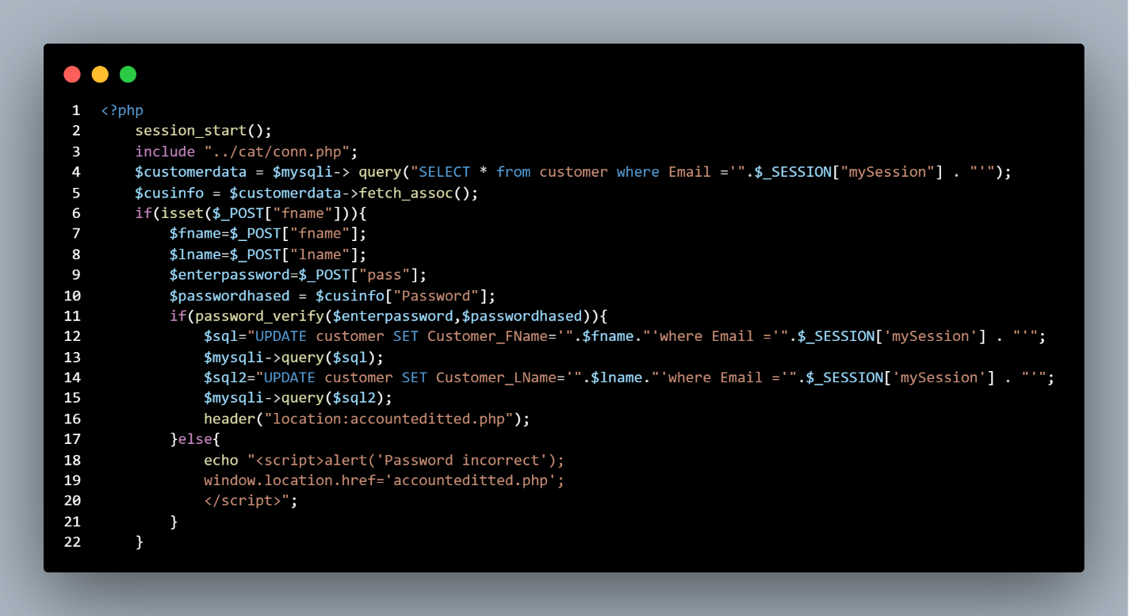 **Figure 24.1: Update PHP code Snippet**

The figure above is the PHP code after the user input their new information and submitted by form action. First, the Php will link to the server so that the data can be retrieved and assigned from the server as the line 2,3 and 4 shown. The “ISSET” is applied because to check the variable is not null. The variables are assigned in line 7 to 10 and if statement used for executing code if the condition is true.

The function “password_verify” verifies that the given hash matches the given password from users. If the password given is match with the hashed, then it proceeds to the line 12 to 16 for updating the User first name and last name to the databases. When the password is not matched with the hashed, then it will proceed to the else statement which is pop out an alert message and will redirect back to the page.

## Delete

PHP  
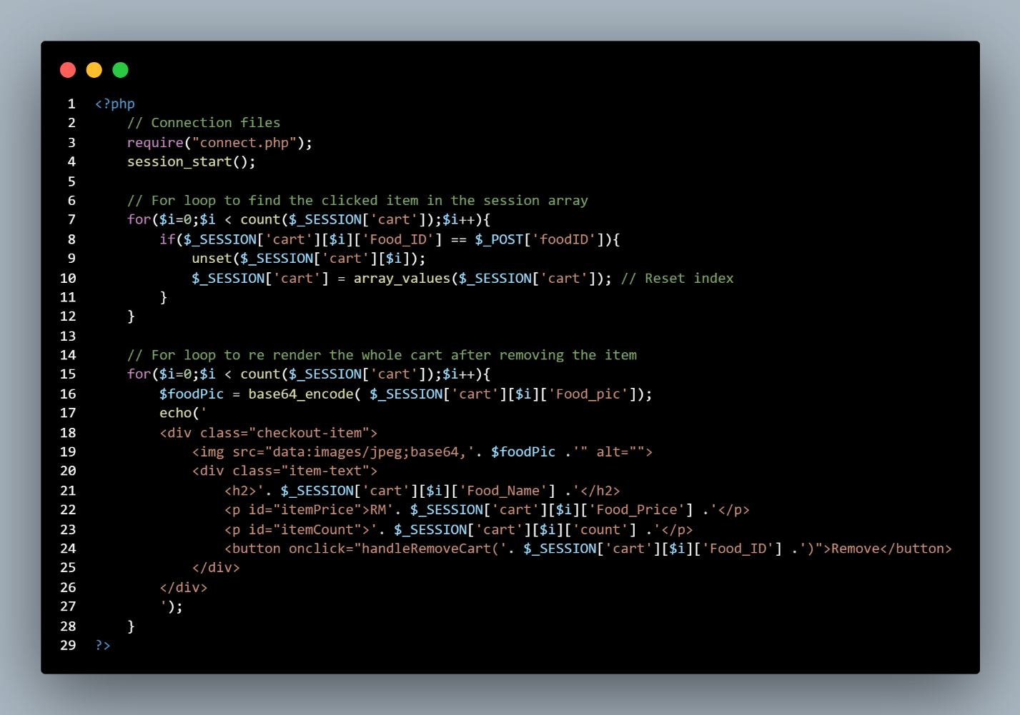

**Figure 25: Delete PHP code Snippet**

The figure above is the delete function of cart when user delete item from the shopping cart. First the code will establish a connection to the server then it will loop through the current shopping cart and find the selected item in the shopping cart array. Then it will delete the matches item from the shopping cart array and rearrange the array index. Once the item is deleted from the shopping cart then another for loop will be initiated to re-render the shopping in the html form.

## Login & Signup

### Login

#### HTML

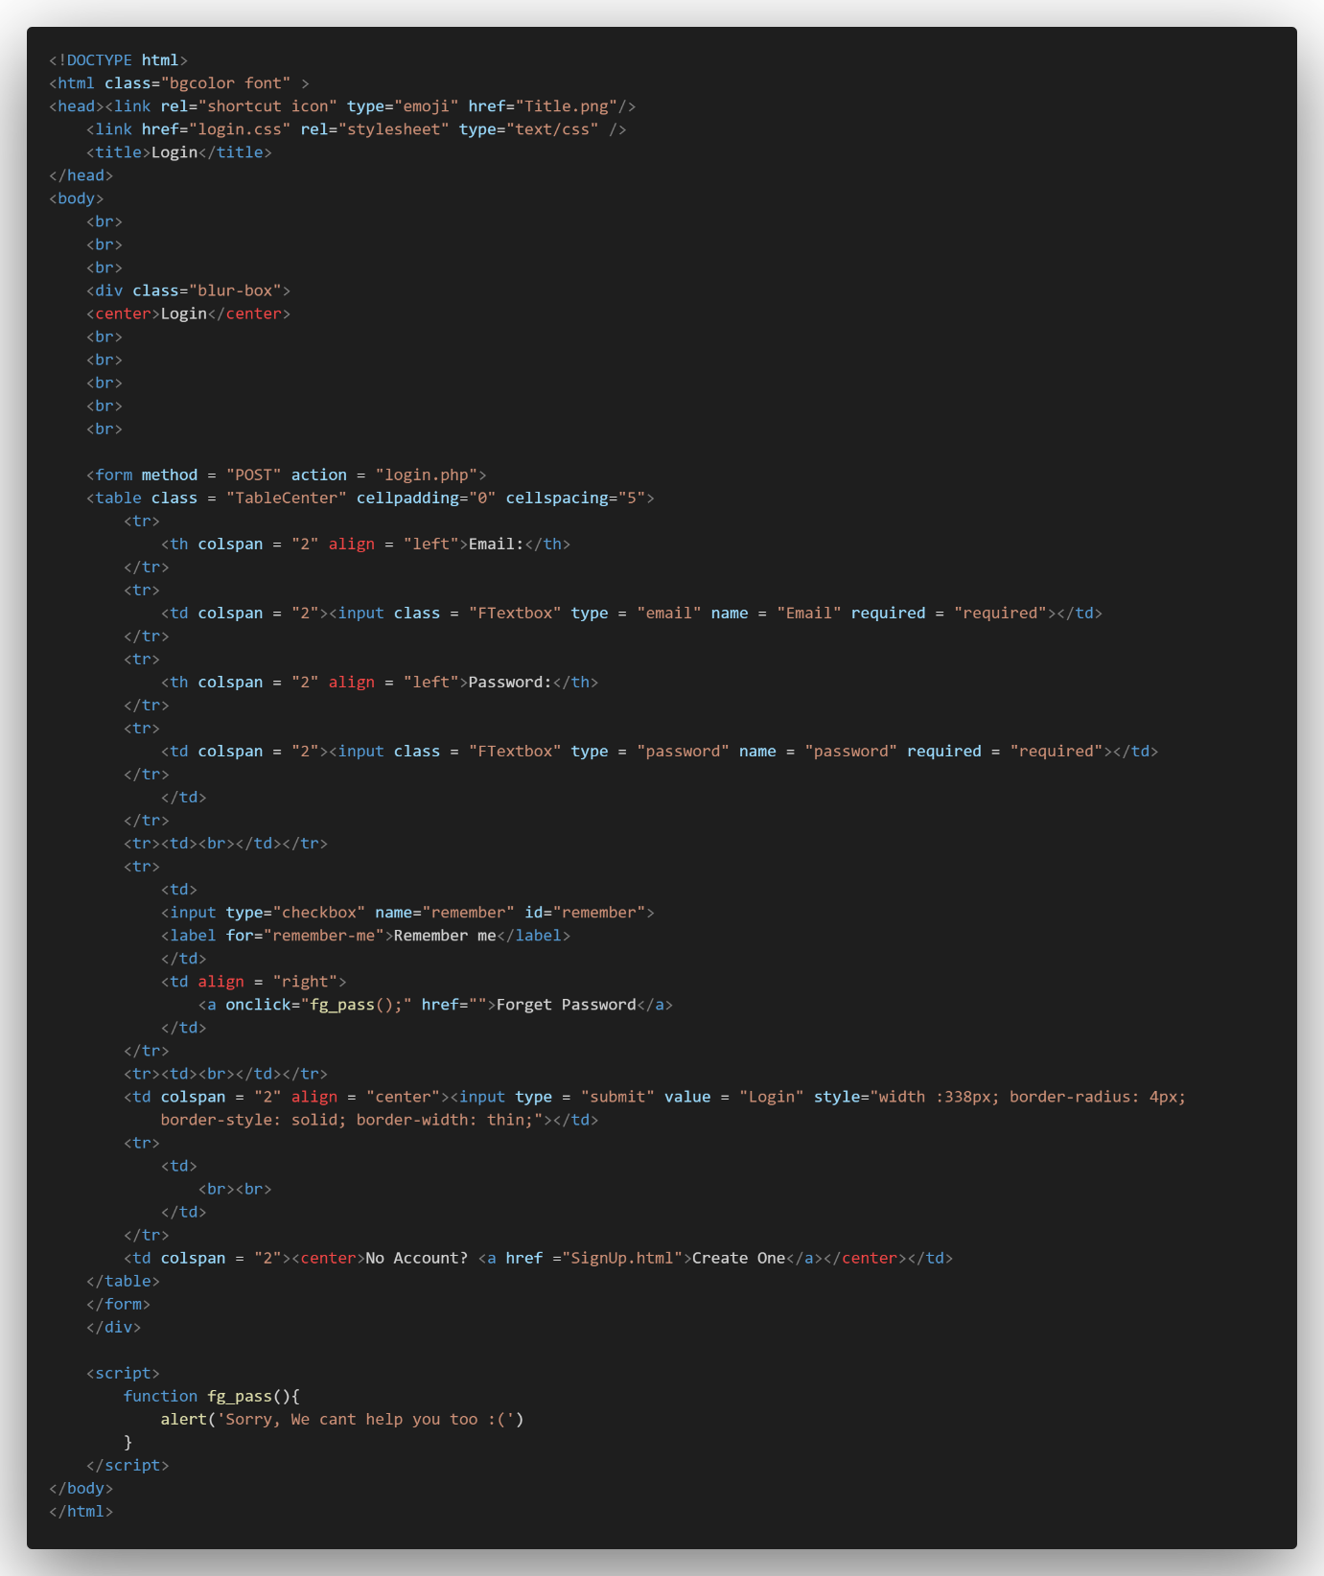

**Figure 26: Login HTML code Snippet**

The code above is the HTML code of the login webpage. The login webpage is presented with “table” tag with POST method to send the data to the server, the table tag is to organize the grid of the table column, table row, and input box. This HTML file is assisted by an external CSS file to make some touch up of the webpage.

The CSS file is linked at the line 4 of the file. The action of the form will be passed to login.php located at the same directory of the file. There are two buttons in this page and there is a link to create a new account in case the user doesn’t have an account, the other button is a forget button in case the user forgets his password of his account.

The user is required to use his registered email address and the password of his account in order to login into his account. Upon the click of the login button, the html file will post the user input to the login.php file.

#### PHP

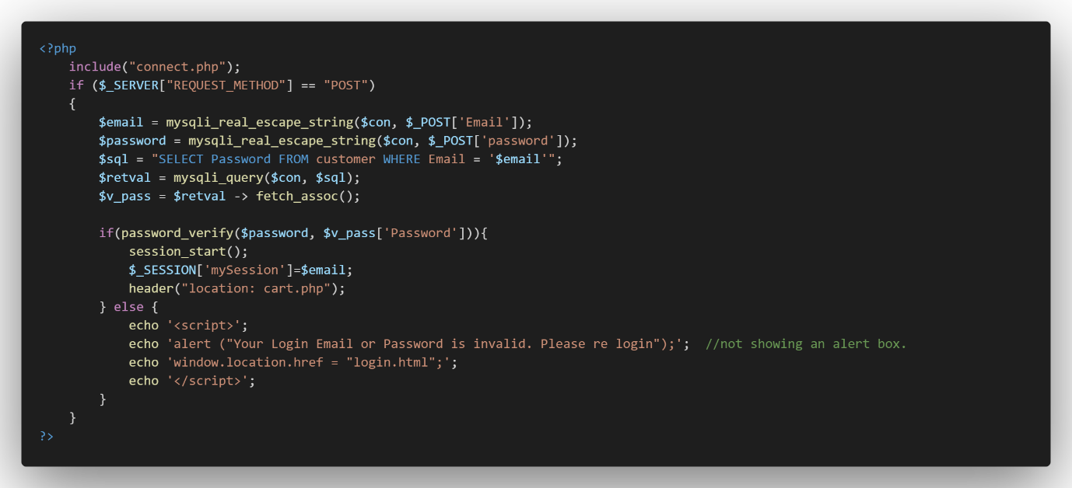

**Figure 26.1: Login PHP code Snippet**

The code snippet above is the PHP code for the login.html. The main function of PHP is communicate with MySQL which store data. This login.php file extract the user input data with the $_POST function (Email and Password) from the login.html and compare the user input with the data from the database.

If the Email and the password match the data in the database, the user can log in into their account, if the Email and the password doesn’t match the data in the database, the page will pop up an alert that prompt “Your Login Email or Password is invalid, please re login”, the webpage will link the user back to login.html to allow the user to enter the email and password again.

Since the password in the database is stored using hash function to encrypt the password, the php require a function named “password_verify(‘user input variable’, ‘result from database[Name]’” to check whether the user input is match with the hashed password in the database. If the user key in their email and password correctly, the session of their account will be created, and they may log in into their account. (PHP, n.d.) (McFedries, 2018)

### Sign Up

#### HTML

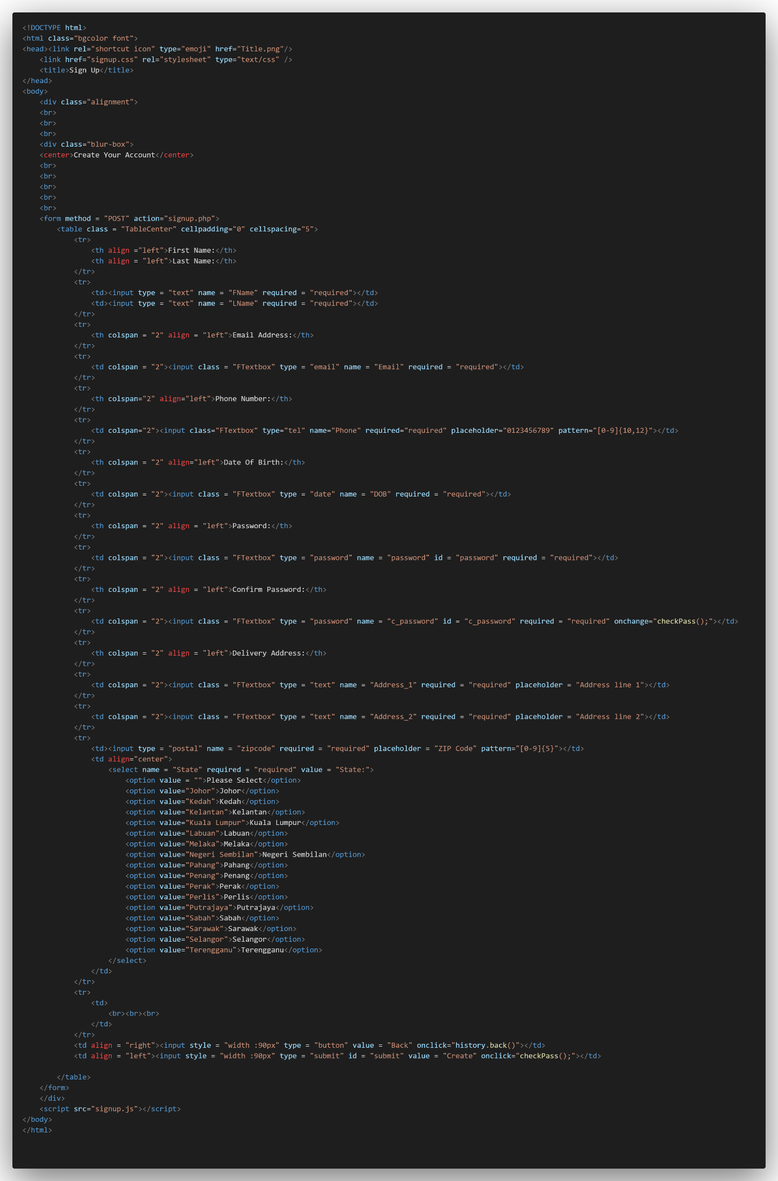

**Figure 27: Login HTML code Snippet**

The code above is the HTML code of signup function. Same to login webpage, the webpage used table tag to organize the grid of the input box in the form. The HTML code also uses POST method to send user input data to the server. This HTML code is also assisted by external CSS file that link at line 4 of the code.

The action of this file will be sent to signup.php that helps to communicate with the server. This HTML file is also linked to a JavaScript file named signup.js that helps to validate whether the password and the confirmation password is the same. Others than that, input boxes such as Phone Number, Date of Birth, Delivery Address, Zipcode, and state is validated by Regex pattern in the HTML form.

Users are required to create an account if they don’t have an account for the website. There are required to enter their personal details such as name, Email, phone number, date of birth, and delivery address. Because users use their email as their account name, therefore email cannot be the same.

#### PHP

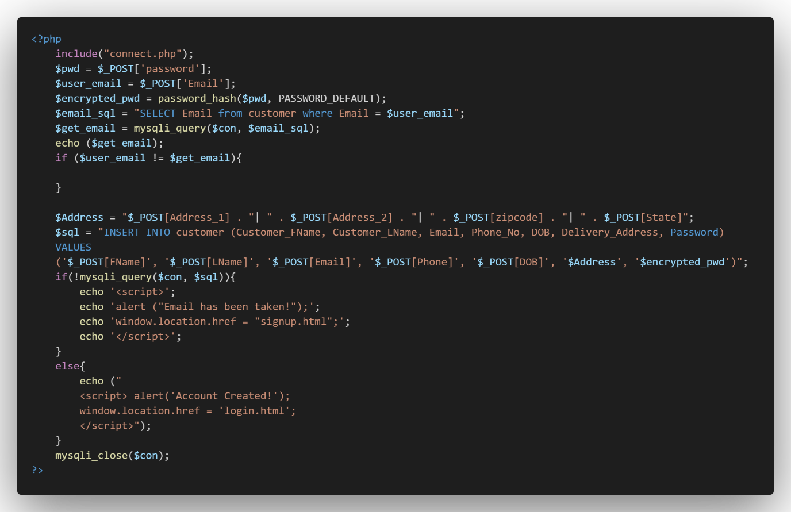

**Figure 27.1: Login PHP code Snippet**

The code above is the php code of signup.php. The function of this PHP code is to retrieve the user input in the HTML form with $_POST method. The php file will firstly connect to the database and get the user input from the html file. After that, the php file will be combining address line 1, line 2, zipcode, and state into one address line. The php file will be inserting the user details into the database, since password is something private and require security attention, the password will be saved into the database after it had been hashed, so the password won’t be showing in plain text in the database. If the Email entered by the user is taken, the webpage will prompt an alert that says, “Email has been taken!” to make sure there will be no duplicate email in the database.

### Self-Created CSS & Java

#### Tay Ze Kang

##### CSS

**Figure 28: Self-Created CSS Example**

The CSS below is self-created CSS code. The CSS code makes an overlay glass effect as above.

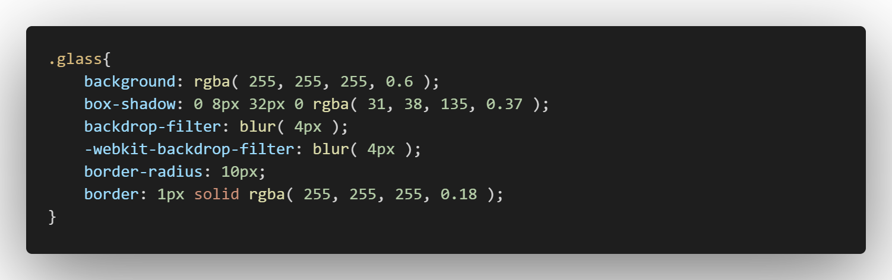

**Figure 28.1: Self-Created CSS**

The first line of the code defines the colour of the glass box’s background colour, while the first three numbers determine the colour and the last number determine the transparency of the colour.

The second line of code determines the colour, boldness of the box shadow, same as the background, the first three number determines the colour, and the last number determines the transparency of the border

The third line of the code gives a blur filter onto the box. You can tune the blur filter by changing the number inside the column.

The fourth line of the code uses the web program’s filter kit to further enhance the blur filter.

The fifth line of the code gives the box a small curve at the corner of the box which is adjustable depending on your personal preferences.

The last line of the code gives the box a border, the first value determines the box border thickness, the second value determines the box border style and the last value determine the colour and the transparency of the box (Purdila, 2019).

##### JAVASCRIPT

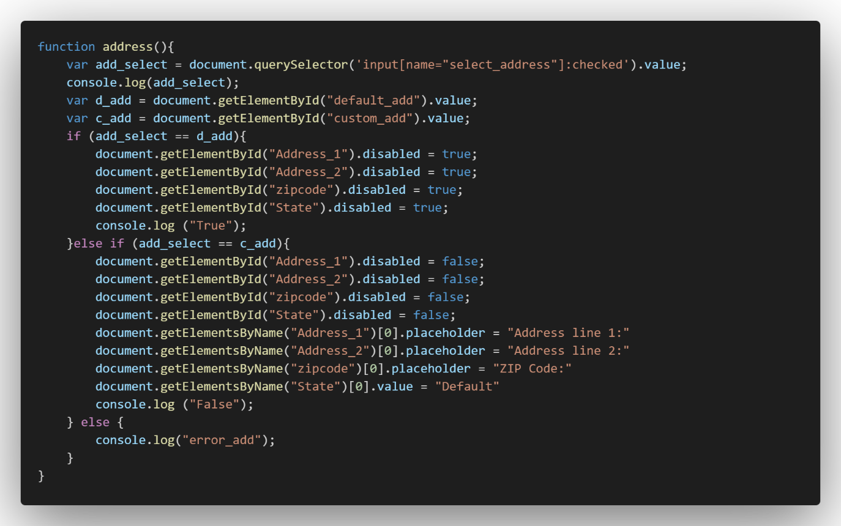

**Figure 29: Self-Created JavaScript**

The function of the JavaScript code above is to toggle disable the Address input box in the payment page. When the user chooses Default Address, the JavaScript will disable the Input box for input box with the ID “Address_1”, “Address_2”, “zipcode”, and “State”. The first line of the function will read the value of the radio button that are locate above the input box. If “Default Address” is checked, then the JavaScript will disable the input box, if the “Custom Address” is checked, then the JavaScript will allow the user to enter their details in the input box.

#### Tee Seng Loong

##### Text Description automatically generated with medium confidenceGraphical user interface, application Description automatically generatedCSS

**Figure 30: Self-Created CSS**

The figure above is the code of dropdown in the Category page when it is clicked. First a class element called section1 will cover the code and toggle the visibility of its content. After the content is hidden, background colour and position is applied to the content.

Padding and justify content is applied for positioning the content of dropdown item. In line 17, the border is set for every item so that the content will look organized when it is clicked. Also, the cursor is applied for the dropdown icon so that when user hover over the icon, the user will know that the icon is clickable.

##### JAVASCRIPT

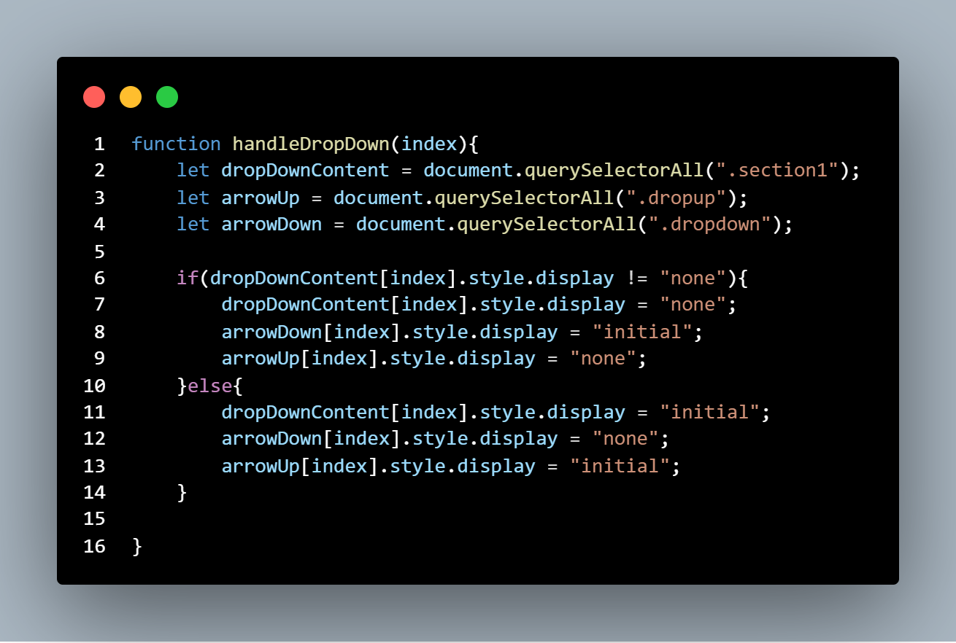

**Figure 31: Self-Created JavaScript**

The figure above is the JavaScript code of the dropdown category when user clicks on the arrow down the JavaScript function will be executed based on the line 1 to 16 written. As the line 6 to 9 will set the dropdown content will be viewable by changing the display none to initial. While line 11 to 13 will hide the dropdown content by setting the display to none from initial.

#### Vanness Goh Ching Yi

**

**Figure 33: Login Button Before Mouseover**

**Figure 34: Login Button After Mouseover**

**Figure 32: CSS of Button**

Class btn-1 is set to have a left margin of 70px to separate the button from other button in the left side. The width and height are set to 150px and 30px respectively. Border are set to none initially but will be overwritten to have solid black border with the border size of 3px and border radius of 15px. The colour of background is set to red. The transition is set to ease-out which mean it will fade in with a slow end of 30ms when user remove their mouseover. Font size is set to 16px, and outline is set to none to remove the 3D feel of button. Position is set to relative to enable the adjustability of button relatively to its normal position and enable pseudo element to work well. z-index is set to 1 to bring it forward 1 layer.

Class btn-1:hover is btn-1 with pseudo class hover, which when user mouseover the button, user’s cursor will change to pointer cursor and colour of “LOGIN”.

Class btn-1::before are btn-1 with pseudo element before which are layer before the btn-1, transition is set to all ease which have an effect of fade in with slow speed to and gradually increase to fast speed of 0.5s and reverse back, left and right are set to 50% to let the effect start from center of button. Opacity is set to 0 to hide it and content are set to ‘’ to have a layer to apply those effect and the background of it are set to white.

Class btn-1:hover::before are btn-1 with both pseudo class hover and pseudo element before, which when user mouseover the ::before button, border radius will set to 15px, and transition are set to all ease with 0.5s. Left and right are set it to -1 to make it squeeze into center of button and opacity of 1 to show the this button. z-in is set to -1 to bring it backward to show the border of btn-1.

##### JAVASCRIPT

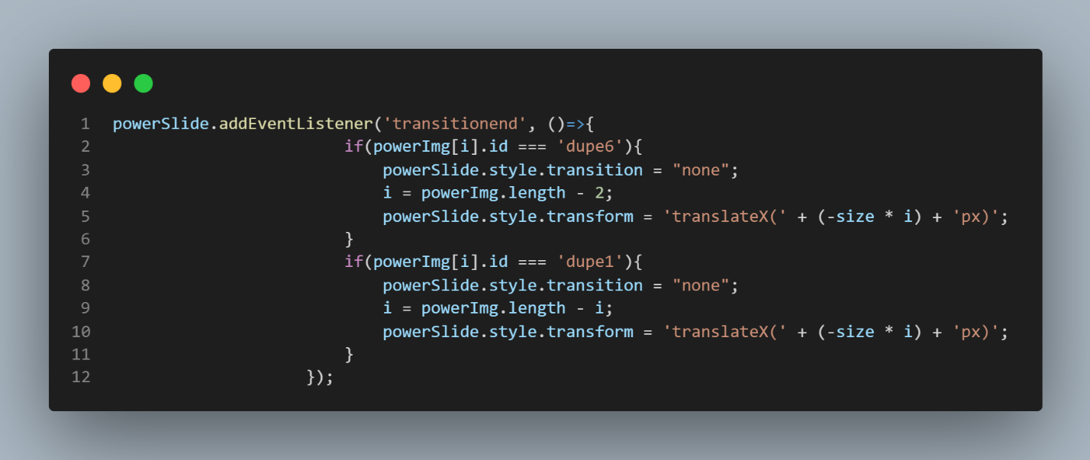

**Figure 35: JavaScript inside Power Slide**

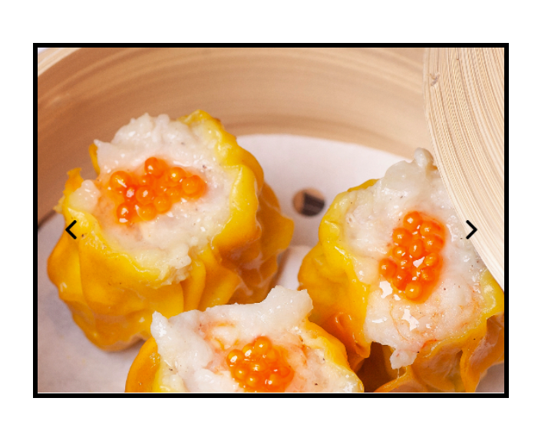

**Figure 36: Power Slide**

This JavaScript is for when image dupe 6 is selected and press the left arrow button again. If statement is used to have if powerImg with the iteration number id are same with dupe 6, the powerSlide’s transition to set to none to let it transfer all the way back to the final picture without the transition effect. The iteration is then set to the length of powerImg to minus 2. powerSlide’s transform is set to translate the x-axis of the whole image client to the size of client times the iteration to move to previous slide. The next if statement is essentially the same with just for the next button which when dupe 1 is selected the next button click will jump back to first image.

# Main Section

## Main Page (Vanness Goh)

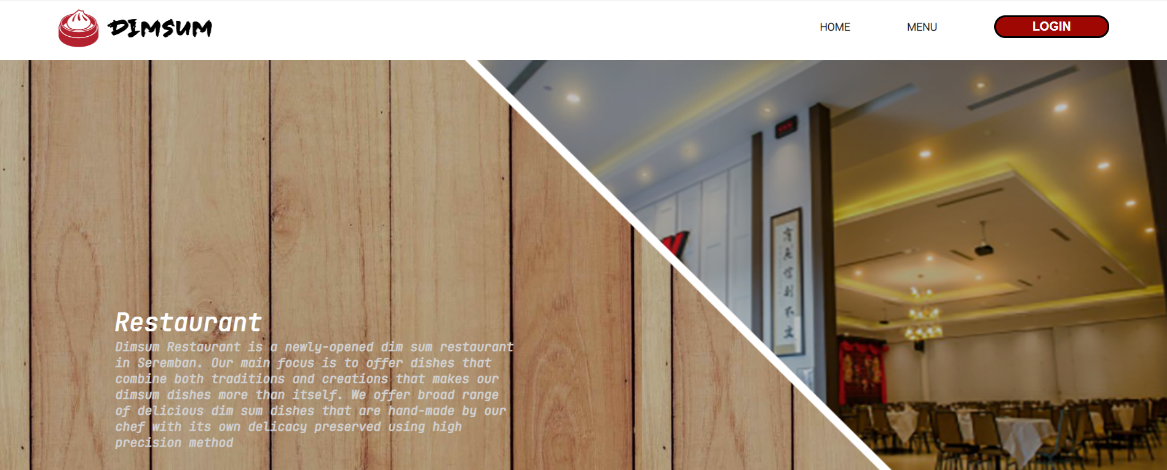

**Figure 37: Header and Home Page**

This is the home page before login to user account, users are able to click to “Home” to return to this page and “Menu” to be redirected to menu page to see all the available dim sum. By clicking “Login” button, users will be redirected to login page to login to their account and are able to create their account on the login page as well.

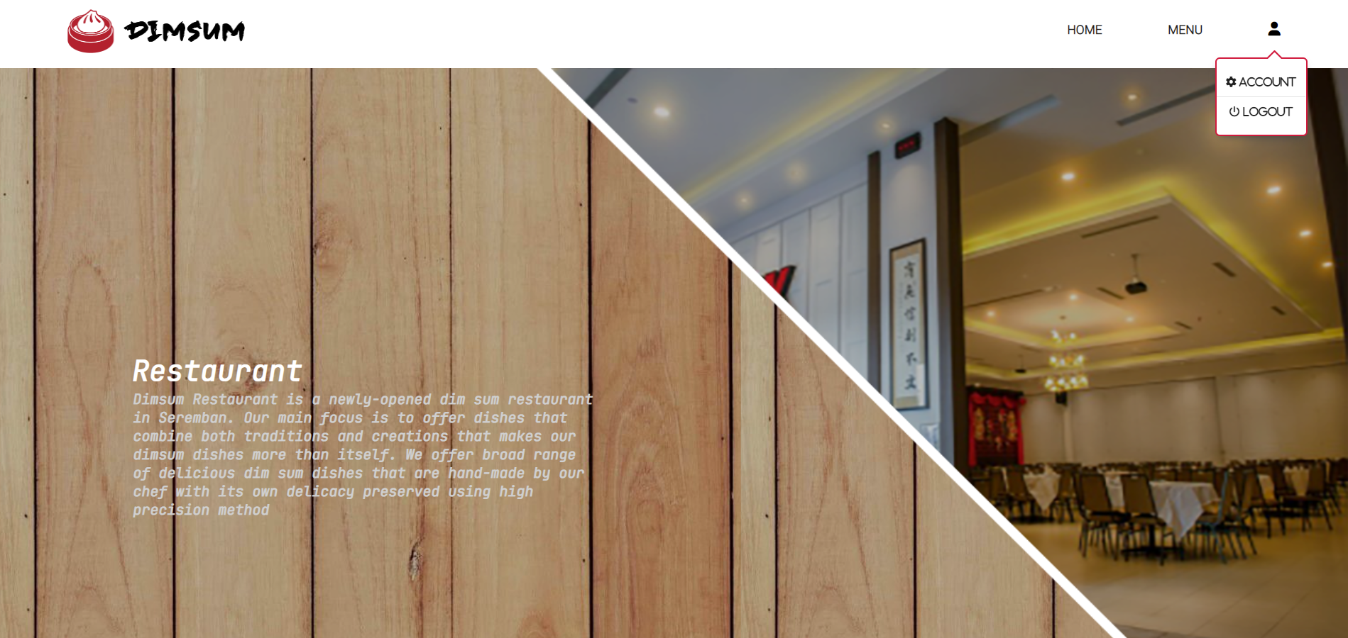

**Figure 38: Login Home Page**

This is the home page after login to user account, logged in user will have two addition button which are “Account” and “Logout” which user will be able to edit their account information and log out their account respectively.

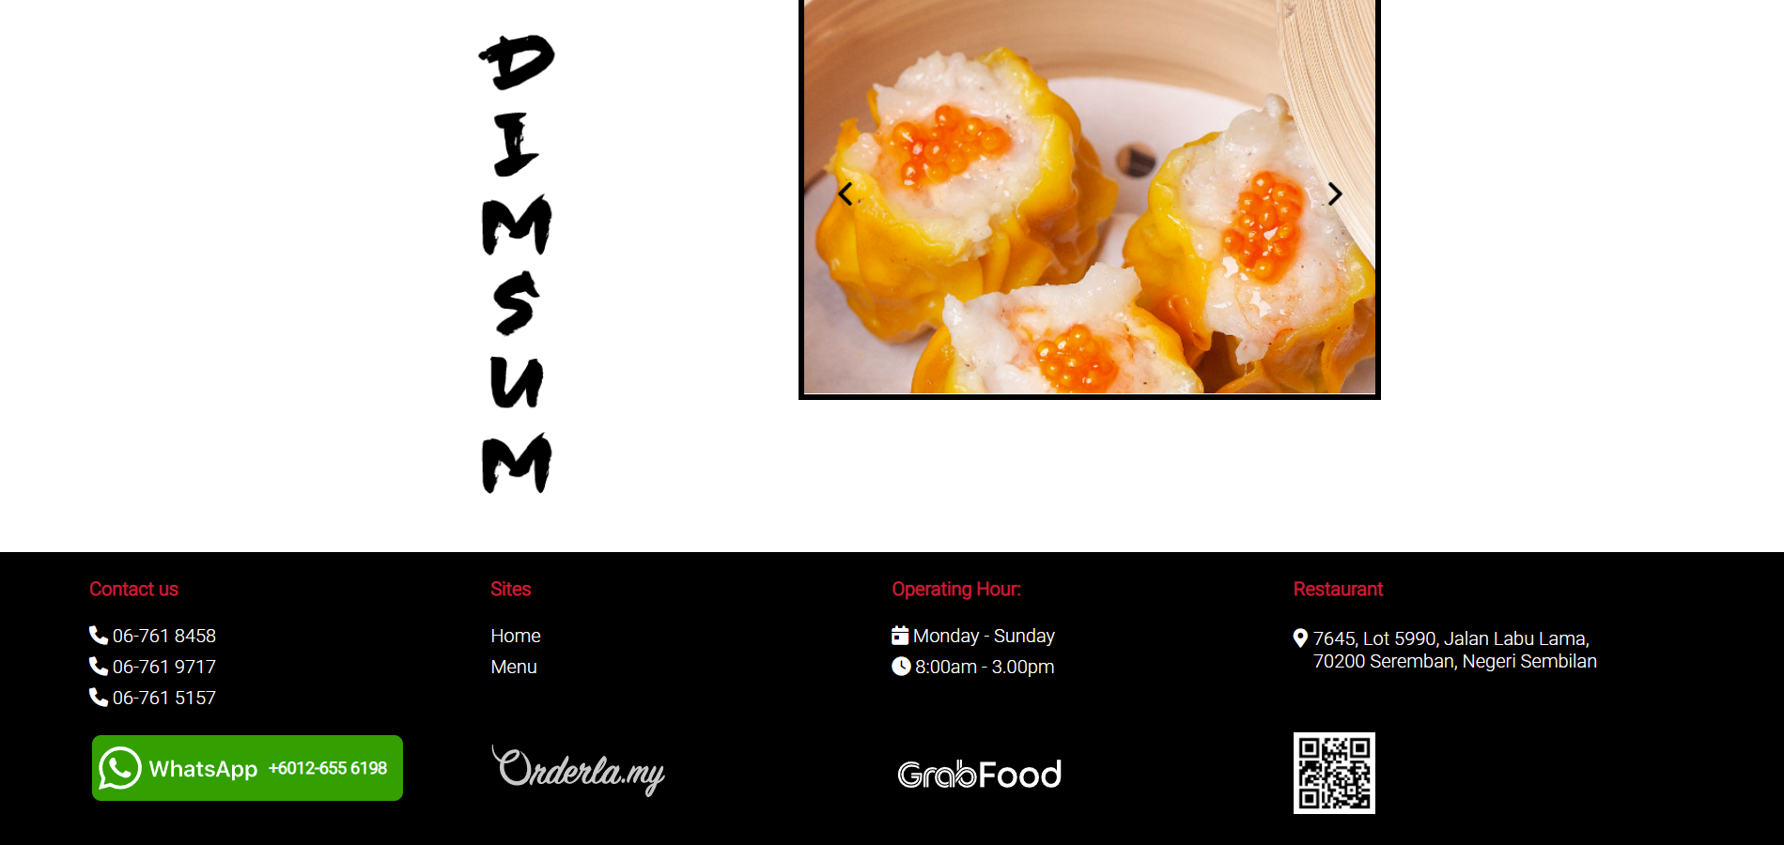

**Figure 39: Footer**

This is the end of home page. Users are able to click on the arrow to navigate on the food slide to check out our recommended dishes at the top side of this figure. Clickable link at the footer are “Home” and “Menu” at the site section which will redirect to home page and menu page respectively. Another clickable link is “WhatsApp”, “Orderla.my” and “GrabFood” which will redirect to external site.

## Login (Ze Kang)

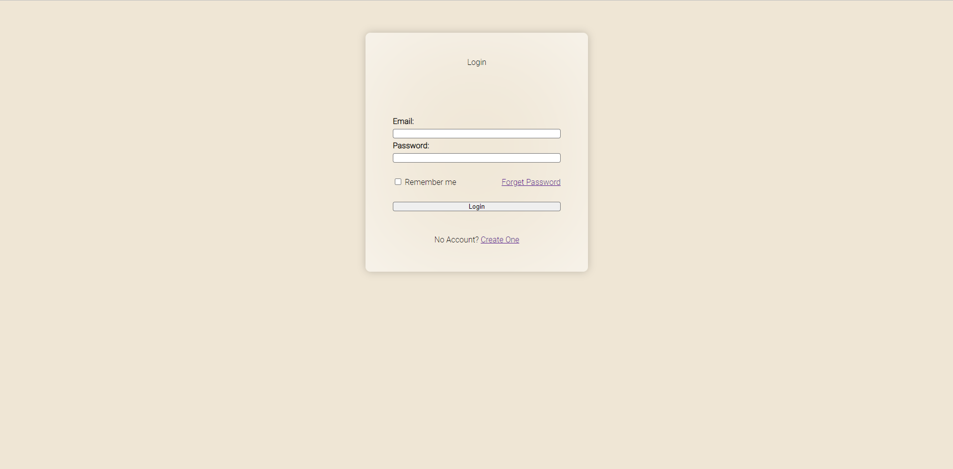

**Figure 41: Login Sample Screen**

This is the User login page for user to login. Users are required to login into their account in order to purchase the Dim Sum online. User can enter his/her email at the email input box and his/her account password at the password input box. If user forget the password, the user can click the “Forget Password”. After the user enters the email and password, the user is allowed to login by clicking the login button.

## Sign Up (Ze Kang)

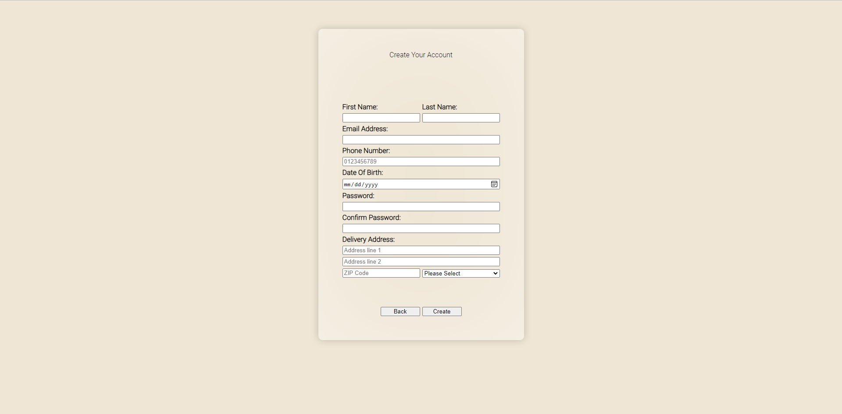

**Figure 42: Sign Up Sample Screen**

This is the Sign Up page of the webpage in case the user doesn’t have an account and is interested to create an account. To create an account, users are required to enter all the details that are required. Those details that are require is First Name, Last Name, Email Address, Phone Number, Date of Birth, Password, Confirmation Password, and Delivery Address. Email will be checked in the database to avoid duplication. Password and Confirmation Password will be validated sure that both of them are same to create an account.

## Edit Account Details (Seng Loong)

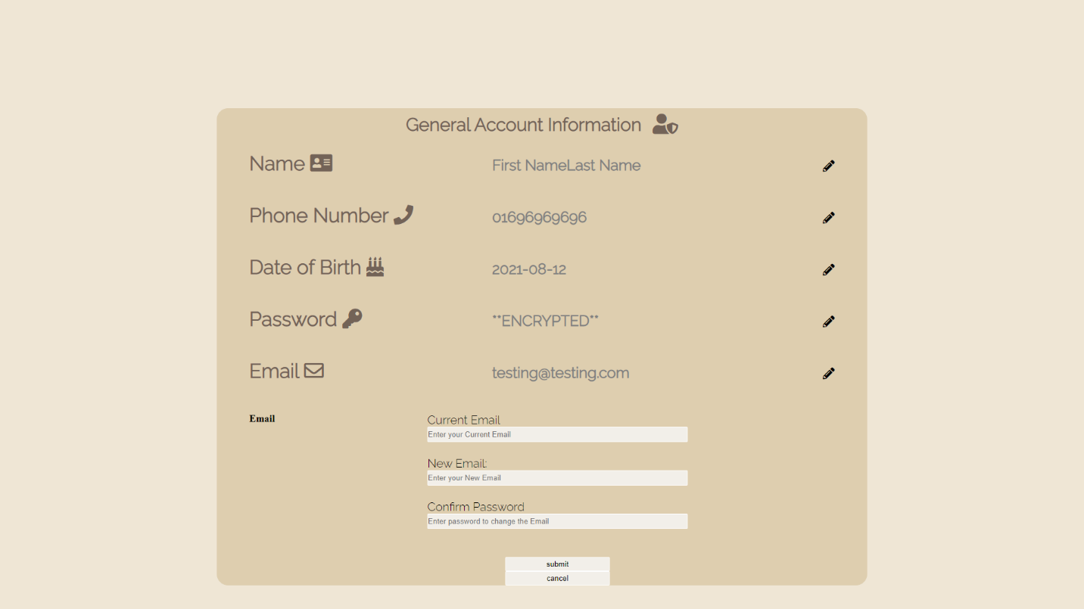

**Figure 43: Edit Account Details Sample Screen**

When the user clicks on account link, the user’s information will be displayed as the figure above shown such as name, phone number, Date of birth, password, and email. Users are able to edit their own information by clicking the pen icon on right where it will switch to editing mode. User will then be prompted to enter their new information and their password to change their information. An error message will pop up if the user submits with the incorrect password and will be redirected back to the page.

## Food Menu & Cart (Ze Kang)

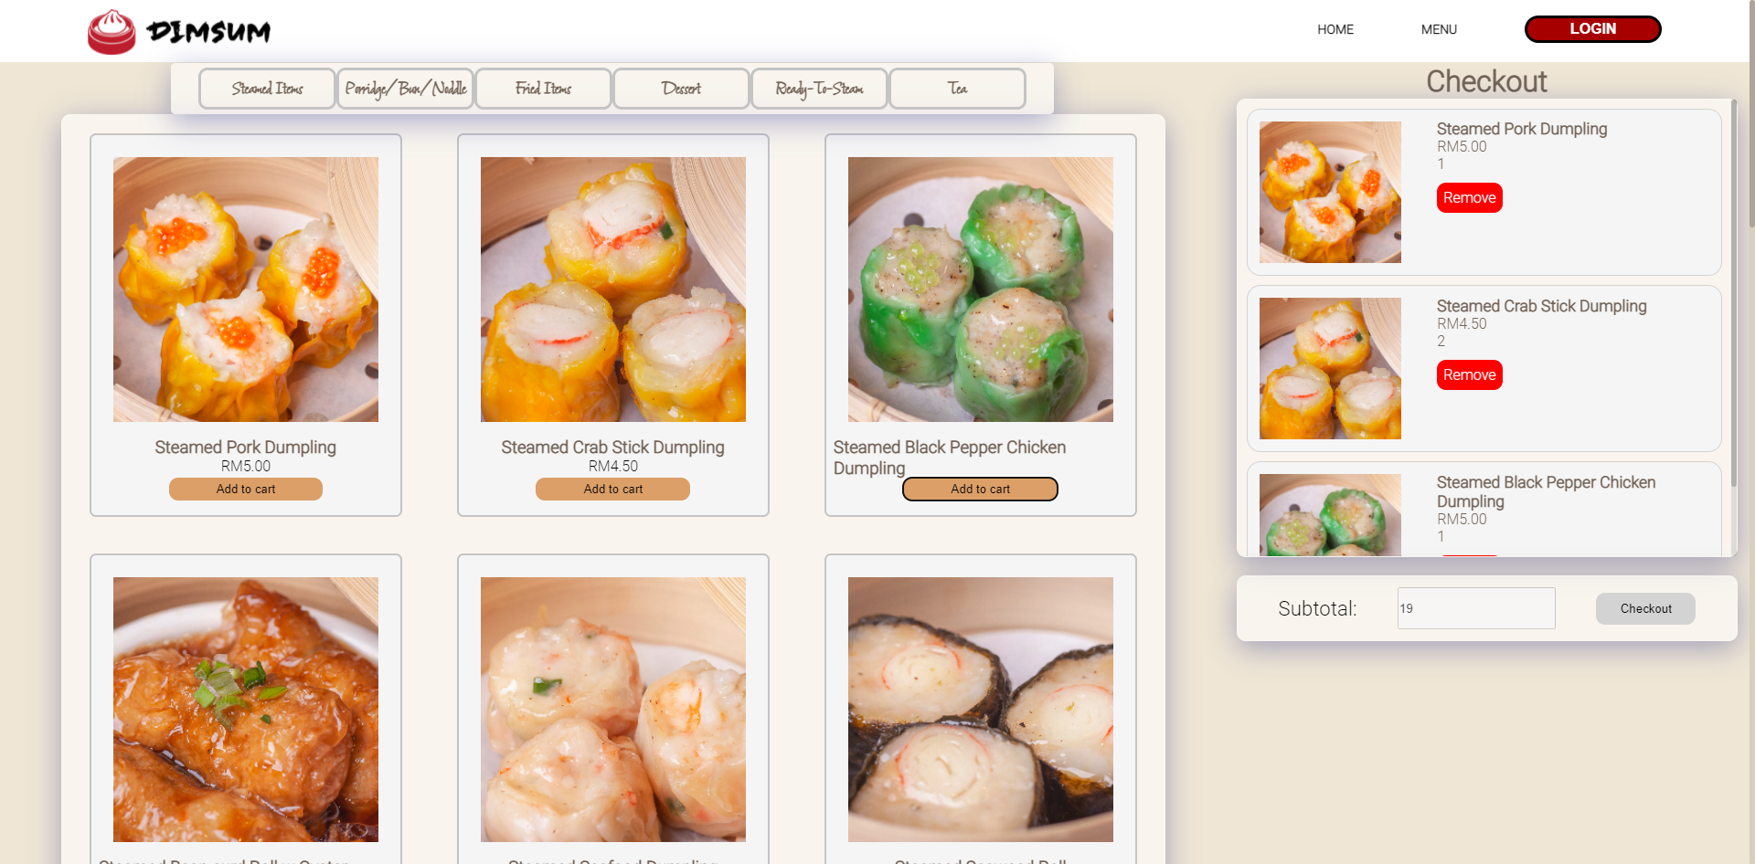

**Figure 44: Food Menu & Cart Sample Screen**

The figure above is the Food Menu and Cart page of the website. Registered users can buy foods online at this page, they can choose their desire food and add them to their cart. After adding the food to their cart, they can choose to remove the food from the cart or checkout to the payment page. The page will show the subtotal of the foods added to the cart and allows the user to have a summary of what they added to the cart.

## Payment (Ze Kang)

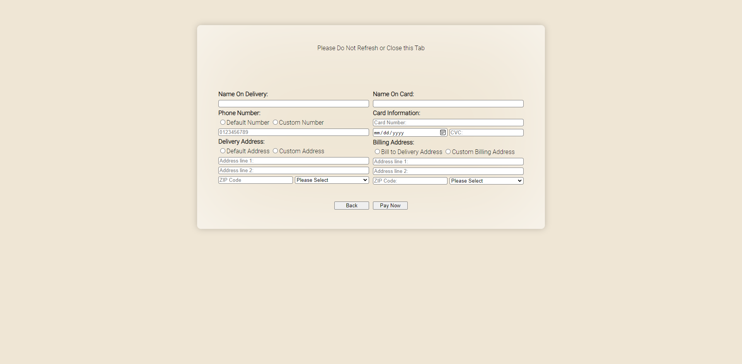

**Figure 45: Payment Sample Screen**

This is the Payment page of the website. This page will be triggered after the user tap the checkout button in the Cart page. User are required to enter the details that are required in the webpage. In Phone number, Delivery Address, and Billing Address, user can choose to use default value or a custom value. If the user chooses the default value, the webpage will get the data from the database and show It in the webpage.

## Admin Login (Ze Kang)

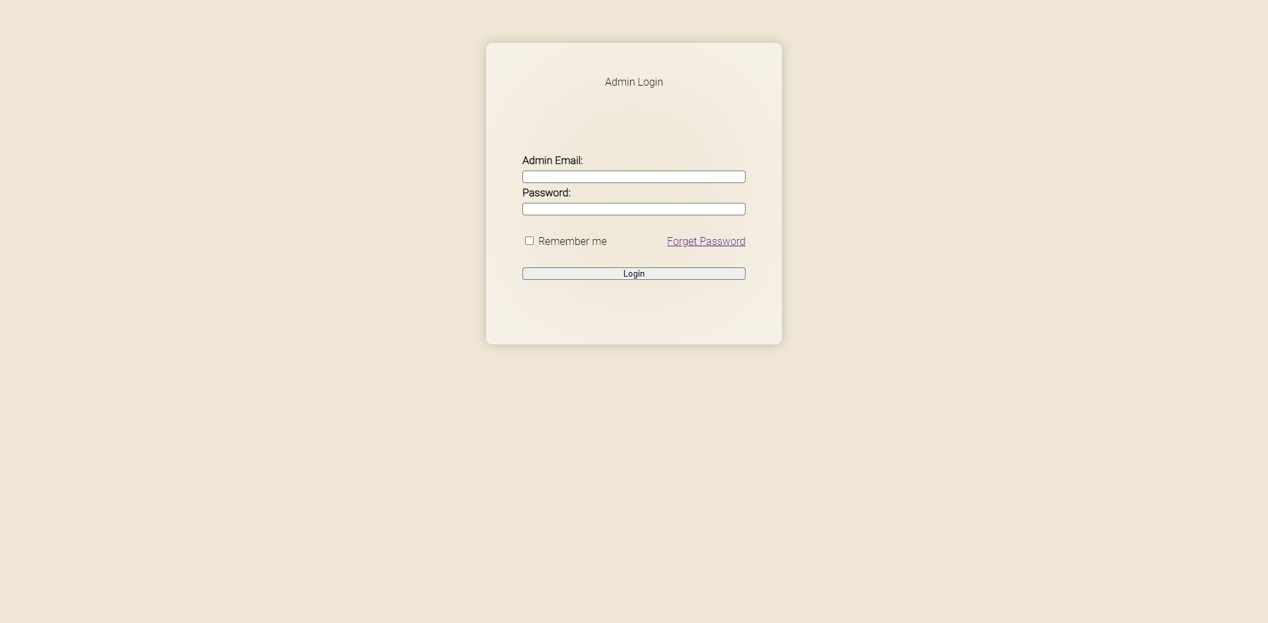

**Figure 46: Admin Login Sample Screen**

This is the admin login page for user to login. Admin are required to login into their account in order to access the admin function which is add or make changes to the food and category database. Admin can enter his/her email at the email input box and his/her account password at the password input box. If admin forget the password, the user can click the “Forget Password”. After the admin enters the email and password, the admin is allowed to login by clicking the login button

## Add/Change Category and Foods (Seng Loong)

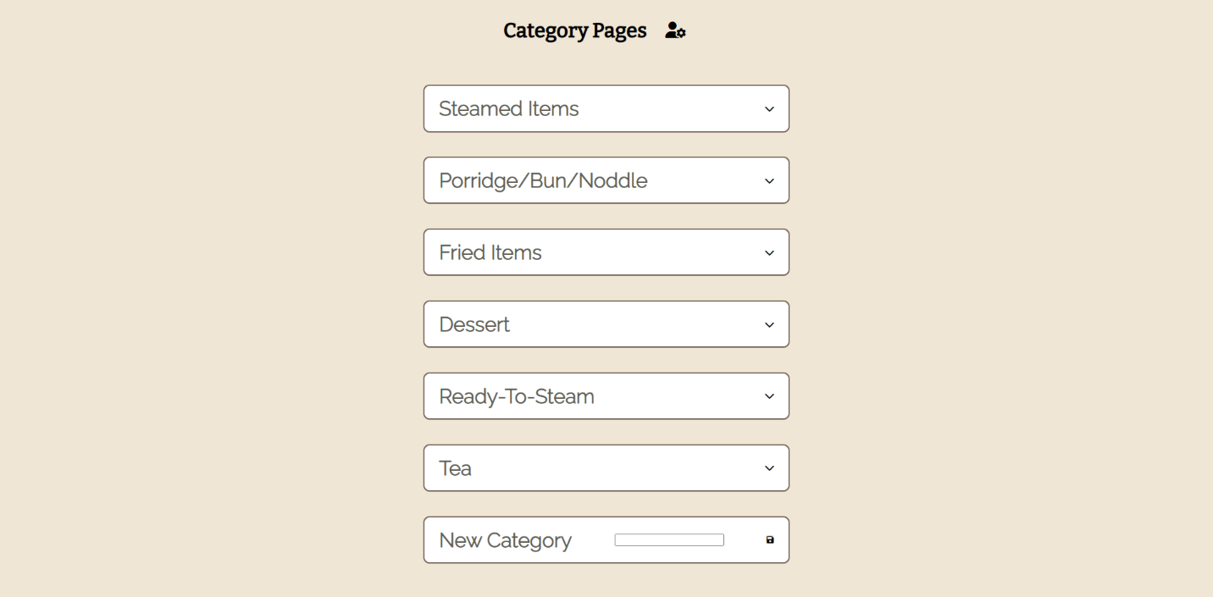

**Figure 47: Add/Change Category and Foods Sample Screen**

After the admin login into the admin page. The user will first need to click on the icon arrow down to trigger the dropdown menu, the admin will then be able to modify the item name and price based on each item shown by clicking the pen icon. After user done modifying the item, a save button is provided to save the modification. User can also add a new item using the input field below the category. In additional, user can also add a new category by typing the new category name into the input field and clicking the save button.

# Conclusion

In conclusion, this final assignment tests us on different level on web development skill including HTML, CSS, JavaScript, and PHP. Throughout this assignment me and my group member had learned many other important skill others than programming and it is designing a wireframe, designing a ERD diagram and designing the structure of the database. Moreover, this assignment also taught us how to work in a group and communicate with each other efficiently in order to present a complete functioning website that is selling Dim Sum online.

# Workload Matrix

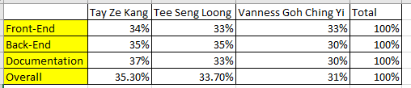

# References

McFedries, P. (2018). *Web Coding & Development ALL-IN-ONE for dummies.* Canada: John Wiley & Sons, Inc.,.

PHP. (n.d.). *password_hash*. Retrieved from php: https://www.php.net/manual/en/function.password-hash.php

Purdila, A. (2019, Jan 15). *Two Ways to Create A Frosted Glass Effect in CSS*. Retrieved from envato-tuts+: https://webdesign.tutsplus.com/tutorials/how-to-create-a-frosted-glass-effect-in-css--cms-32535

Ajax introduction. (n.d.). Retrieved November 14, 2021, from https://www.w3schools.com/xml/ajax_intro.asp.